**IGDTI BASIC COMPUTER NOTES**

**INDEX**

1. Computer Fundamental…………………………………………………5
   1. Computer System……………………………………………………………………………..7
   2. Devices of computer………………………………………………………………………..8
   3. Computer memory………………………………………………………………………….13
   4. History of computer………………………………………………………………………..17
   5. Generation of computer…………………………………………………………………..18
   6. Ketboard keys…………………………………………………………………………………19
   7. Types of computer…………………………………………………………………………..22
   8. Full form……………………………………………………………………………24
   9. Virus & Anti-Virus…………………………………………………………………………..25
2. Desktop concept……………………………………………………………26
3. Notepad………………………………………………………………………..30
4. Wordpad………………………………………………………………………………..37
5. Ms-paint……………………………………………………………………….48
6. Microsoft office word (winword)………………………………………..63 
   1. HomeTab………………………………………………………………………**……**……..64
   2. Insert tab…………………………………………………………………………..73
   3. pagelayout………………………………………………………………………...........84
   4. ReferenceTab…………………………………………………………………….92
   5. Mailing……………………………………………………………………………..97
   6. Review…………………………………………………………………………….100
   7. view………………………………………………………………………………..105
7. Short Keys winword……………………………………………………………109
8. Microsoft Office Powerpoint……………………………………………….111
9. Ms- Access………………………………………………………………………….122
10. Microsoft Office Excel……………………………………………………….135

i) Excel Functions……………………………………………………………..155

1. Excel Short Key ………………………………………………………………..185
2. Extention name………………………………………………………………….184
3. Assigment …………………………………………………………………………187

**DEEPAK SHARMA Computer fundamentals**

Q.1 **what is computer ?**

Computer is an electronic machine made up Of many parts .That can store Data , find & arrange information ,calculate amount and Control other machine *.*

Mouse

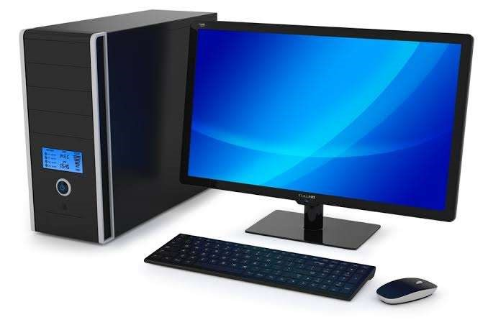

Monitor

Cpu

(

Central Processing Unit

)

keyboard

Q. 2  **Computer organization ?**

Computer has divide in two parts. 1. Hardware. 2. Software.

**Hardware -** hardware is the physical component of computer system that computer require. that we can control computer’s operation. the hardware consist of : input , output & memory.

* Physical part of computer is called hardware.
* You can feel & touch.
* Computer is hardware which operate under the control of a software.
* If hardware is damaged, it is replace with new . • Hardware is not effected by computer virus.

**Software -**  software is a set of program, data or program used to operate computer and execute specific task. Software has divided in

two part.

1. System software 2. Application software.

# Computer system

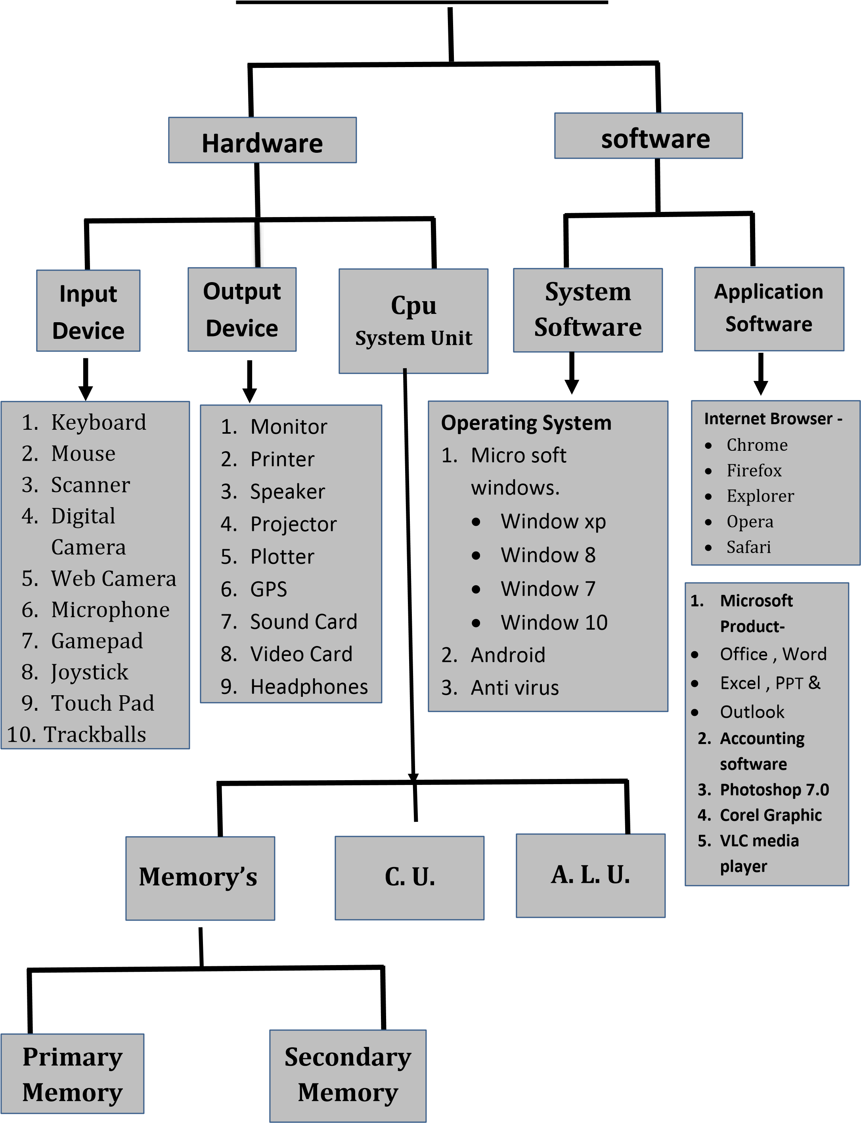

## INPUT DEVICES

An Input Devices Is piece of Hardware used to provide Data To A Computer used for interaction and control . Input Devices Is Called “Pheripheral Devices” Also .

The Most Commonly Used Input Device On A Computer Are The Keyboard & Mouse.

**KEYBOARD** - A Keyboard Is A Basically A Board Of Keys . The

Keyboard Is A One Of The Primary Input Devices .

There are five main parts of desktop keyboards.

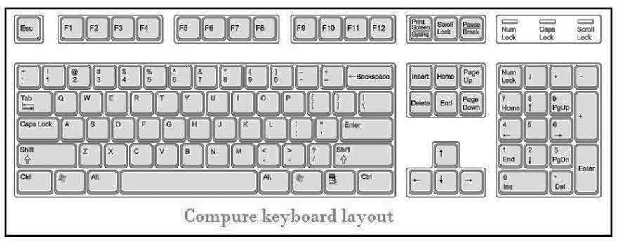

**Function keys**

**Indicator lights**

**control keys**

**Navigation keys**

**Numerical keys**

**Typing**

**(**

**Alphanumerical)**

**keys**

**Mouse** - A Computer Mouse Is An Input Devices That Used To Move The Cursor To Different Item On The Screen. Items Can Be Moved By Pressing The Mouse Button. Mouse is a pointer cursor.

Function of mouse:

→ **Left button -**  left button used to open any file, folder , application & selecting object.

→ **Right button -** Right button used to open menu bar, property bar of any file & folder and open additional information .

→ **Scroll button –** scroll Button Used Moved Page Up & Down And Its Most Commonly Used To Open A Link On Web Page.



**Left Button**

**Right**

**Button**

**Scroll**

**Button**

**Wire**

## Output Devices

An output device is any pieces of computer hardware which received data from a computer & convert information into human readable form. The form may be – audio, visual, text and hard copy.

**Monitor -** A computer monitor is an output device that displays information in video, audio & text. It used to data processing.

Two types monitor in micro computers:

**CRT monitor**

**(Cathode Ray Tube) LCD monitor**

**(**

**liquid crystal display**

**)**

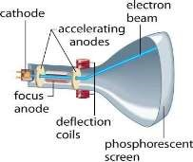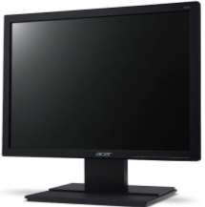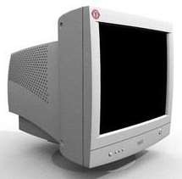

CRT Monitor **-** The cathode ray tube is vacuum tube containing one more of electron gun.

LCD Monitor **-** A flat plain screen that use the liquid crystal display technology and connect to a computer . LCD monitor is the standard display screen for desktop computer .

**Printer** - A Printer Is An Output Devices That Print Paper Document . This

Includede Text , Image , Or Both Combination. The Two Most

Commaom Type Printer Inject And Laser Printer. Printers very in size speed & cost.

**1. How many types of printers ?**

Printers divided into two categories : 1. Impact printers 2. Non- impact printers.

**Impact printers :** its a type of printers that produce character , graphic & image in pieces of paper .that direct connect with the ink ribbon. impact printers involve mechanical component for conducting printers .when these printer has banging noise of needle on paper. its printers faster speeds around 250 word per second. Dot –matrix printer , daisy wheel printer , line printer are examples of impact printers .

**Non-Impact printers :** its a type of printers that produce character , graphic in pieces of paper without striking .that does not hit impact a ribbon print. In this printer no mechanical device used .these work silently. its printers slower speeds around 1 page per 30 second.

Inject & laser printer are example of non – impact printers.



**PRINTERS**



**Impact**

**Printers**



**Non**

**-**

**Impact**

**Printers**



**Daisy**

**–**

**Wheel**

**Printers**



**Dot**

**-**

**Matrix**

**Printers**



**Line Printers**



**Laser**

**Printers**



**Inject**

**Printers**

**Daisy Wheel Printer -** A Daisy Wheel Printer Can Be Used By Typewriters.

**Dot Matrix Printer -**  A Dot Matrix Printers Used 9 To 24 Pins Print Head . Pin

Generate Dot Pattern To Individual Character On The Page.

**Line Printer -** The Character At- To- Time Print Too Slow In A Business.

**Laser Printer -** The Majority Of Laser Printer Use Lights. Laser Shaft The Image In To A Spinning Drum.

**Inject Printer -** The Inject Printer is The First And Most Common Type. There Greatest Advantage Is That They Can Combine Different Color.

# CPU

The Computer Central Processing Unit Is The Brain Of Computer .The Cpu Is Often Simply Refer To Processor.

**Computer Memory -**  Computer Memory Is Any Physical Device Used To Store Data And Instructions . computer memory is the storage space in the computer where data is to be processed .

**Types of computer memory**

**Computer memory**

**Primary memory/**

**volatile memory**

**Secondary memory/**

**non**

**-**

**volatile**

**RAM**

**ROM**

**SRAM**

**D**

**RAM**

**PROM**

**EPROM**

**EEPROM**

**Hard disk**

**floppy disk**

**Magnet tape**

**Pen Drive**

**D V D**

**1. Primary memory -** Primary Memory Is Ram & Rom. Primary memory is a **(volatile)** internal memory of the computer it also know as temporary

memory .primary memory hold the data and instruction on when computer is working . it mean when power is switch off it lost all data .

**Ram**  **-** ram is refer to random access memory know as temporary memory .the data & information in this memory lost when power supply of the computer is switched off.

1. **DRAM** - it stand for dynamic random access memory . it stored information a very short time (a few million second ) .

1. **SRAM** - it stand for static random access memory . it stored information As long time. SRAM are of higher cost and consume more power .

**Rom**  **-** rom is refer to read only memory know as permanent

memory the data & information are not lost when power supply of the computer is switched off. Rom also know as “ non- volatile “ memory.

1. **PROM -** programming read only memory . it right data once and read many Once chip has been programmed , the record information can’t be changed.

1. **EPROM -** Erasableprogrammable read only memory . EPROM chip can that

Retain its data when its power supply is switched off .computer Memory that can store stored data after a power supply has been turned off and back on is called non- volatile.

1. **EEPROM -** Electrically Eraserprogrammable read only memory. EEPROM

Erased by using electric signals .

**2. Secondary memory -** Secondary memory refer to storage devices , such as hard

drives. Secondary memory provide a feature of being non –volatile, which meant it can be hold data with or without electric power supply .

I. **Hard disk -**  Hard Disk Are Flat & Circular Plate Made Of Aluminum Or Glass **.** Hard Disk For Personal Computer Can Store Up To Billion Bytes OfInformation . Data Are Stored On Their Surface.

They are two types 1. HDD (Hard Disk Drive )

2**.** SSD ( Solid State Drive)

**Data storage capacity -**

Data storage capacity is the measurement of how much data can be stored in storage devices.

|  |  |
| --- | --- |
| **Unit** | **value** |
| 4 Bit | 1 Nibble |
| 8 Bits | 1 Byte |
| 1024 Bytes | 1 Kilobytes (KB) |
| 1024 KB | 1Megabyte (MB) |
| 1024 MB | 1 Gigabyte (GB) |
| 1024 GB | 1 Terabyte (TB) |
| 1024 TB | 1 Petabyte (PB) |
| 1024 PB | 1 Exabyte (EB) |
| 1024 EB | 1 Zetabyte (ZB) |

**Smallest capacity -**  Bit

**Largest capacity -** Zetabyte

## System software

* System software is a computer software design to operate the computer hardware and to provide a plate form for running application software.
* System software also provide service to computer user and application programs.
* Example of system software are operating system , devices and utility programs .

**Application software**

Application software is a program or group of program design for special task . Example of an application software include a:

* Word processor
* Accounting software
* VLC media player
* Photo editor • Web browser.

## History of computer

Abacus was the first calculation device was invented in china .

“**Charles Babbage”** Is The Father Of Computer. His Invented The First Calculation Device In 1822. It Was An Only Calculation Machine . **“Lady Augusta Ada”** Is The Mother Of Computer. She Was First Programmer Of Computer In 1642.

**(First Calculation Device) - Abacus**

|  |  |
| --- | --- |
| **Name** | **Years** |
| Abacus | 2000 year ago |
| Nappier‘s Bones | 1617 |
| Pascaline machine | 1642 |
| Leibniz’s calculation | 1671 |
| Babbage engine | 1822 |
| Babbage different Engine | 1822 |
| ABC | 1937-1942 |
| ENIAC | 1945 |
| UNIAC (commercial computer) | 1951 |

**ABC** - Atanasoff Berry Computer (1937-1942) Built The First Electronic Computer .

**ENIAC** - It Was TheFirst General Computer That Called ENIAC - Electronic Numerical Integrator And Computer.

## Generations of computer

|  |  |  |  |
| --- | --- | --- | --- |
| **s. no.** | **Generations** | **Technologies** | **Period** |
| 1 | First | Vacuum Tube | 1946 |
| 2 | Second | Transistor | 1955 |
| 3 | Third | Integrated Circuit | 1964 |
| 4 | Fourth | Large Scale Integrated Circuit | 1975 |
| 5 | Fifth | Parallel Processing | 1990 |

* Second generation in 1955 . it use transistor replace vacuum.

* Third generation made in 1964 Integrated Circuit . these ICS are popular know as chip.

* Fourth generation in 1975 . it used large Scale Integrated Circuit built silicon chip called “ micro processor” .

## Keyboard keys

**Function keys**  - the function keys are lined across top of keyboard Labeled in **f1** to **f12**. These key act as shortcut for performing.

|  |  |
| --- | --- |
| **KEYS** | **USES** |
| F1 | Open display help center |
| F2 | Rename of file & folder |
| F3 | Open a search feature for an application. |
| F4 | ALT + f4 close activate window or close current file |
| F5 | Refresh the page or document window |
| F6 | Move the cursor to address bar in internet browser |
| F7 | Check spelling & grammar in Microsoft word |
| F8 | Select text in winword |
| F9 | Refresh a document in ms-word and send & Receives E- mail in Microsoft outlook |
| F10 | Activate the menu bar of open application |
| F11 | Enter & exits full screen mode in internet browser |
| F12 | Open the save as dialog box in winword |

**Keyboard Symbol Name -** these symbol are essential for their coding purpose .

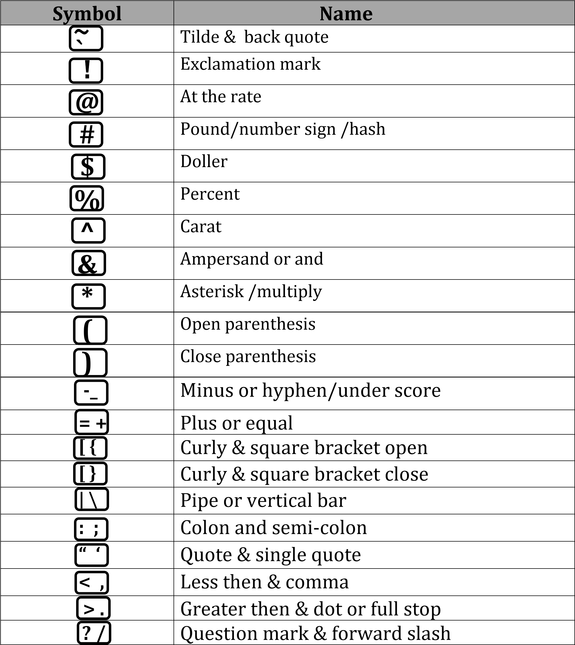

### Control keys -

1. Print scrn - used to screen shot
2. Scroll lock - scroll lock key to stop scrolling of text
3. Pause break - used to pause video
4. Esc Key (Escape Key)
5. Window Key
6. Caps Lock Key
7. Shift Key
8. Alt (Alternate Key)

**Navigation keys -**

1. Insert key
2. Home key - to return cursor to the Beginning
3. Page Up Key
4. Delete key - Delete Any Program
5. End key - to return cursor to the end.
6. Arrow keys

**Indicator lights -**

* 1. First light Indicate to num lock
  2. Second light Indicate to Caps lock
  3. Third Light Indicate To Scroll Lock

**Caps Lock Key** - Automatically Capitalized Until You Press **Space Bar** - Create Empty Space

**TYPES OF COMPUTER**

Computer Can Be Classified In Many Ways . Some Important Classification Are Given Below -

## COMPUTER

**Analog**

**Computer**

**Hybrid**

**Computer**

**Digital**

**Computer**

**Super**

**Computer**

**Mainframe**

**Computer**

**Mini**

**Computer**

**Micro**

**Computer**

**ANALOG COMPUTER -** Analog Computer Are Designed To Process The

Analog Data . Analog Computer Measure The Continuous Changes In

Physical Quantity & Work On Mathematical Arable . These Computer Only Measurement Data LIKE – Air Measurement , Distance Measurement.

Example : Speed Meter , World Clock , Voltmeter .

**HYBRID COMPUTER -** Hybrid Has Feature Of Both Analog And Digital Computer It Is Fast Like Analog Computer And Has Memory Like Digital Computer.

Example :

1. A Processor Is Used In Petrol Pump That Convert The Measurements Of Fuel Flow In To Quality And Price .
2. Hybrid Computer Used In ICU For Measure Patent Heart Beat.

**DIGITAL COMPUTER -**  Digital Computer Are Work On Digital Form . Two Types Of Digital Form – 0 , 1 . That Called Binary Digits. Its Accuracy Very High . Digital Computer Work Only - Adding , Multiply , Subtracts.

Example : Desktop Computer , Laptop & Digital Watch.

**MINI COMPUTER** - These Computer Are Of Multiple User .

**MICRO COMPUTER** – This The Most Common Type Of Computer In 20th Century Like – Tablet Computer , Smart Phone , Programmable calculator ,Video Game.

**MAIN FRAME COMPUTER -** Mainframe Computer Was Created To Distinguish The Large , Institutional Computer To Services Multiple User From The Smaller .

**SUPER COMPUTER -** A Super Computer Is Focused On Performing Numerical Calculation Such As Weather Fore casting .

**FULL FORMS**

|  |  |
| --- | --- |
| SMPS | Switch Mode Power Supply |
| NTFS | New Technology File System |
| LCD | Liquid Crystal Display |
| LED | Light Emitting Diode |
| PDF | Portable Document Format |
| HDD | Hard Disk Drive |
| FDD | Floppy Disk Drive |
| CD | Compact Disk |
| DVD | Digital Video Disk |
| VDU | Video Display Unit |
| LAN | Local Area Network |
| WAN | Wide Area Network |
| WWW | World Wide Web |
| ISP | Internet Service Provider |
| GUI | Graphical User Interface |
| UPS | Uninterruptible Power Supply |
| BSNL | Bharat Sanchar Nigam Limited |
| SIM | Subscriber identity module |
| VIRUS | Vital Information Resource Under Seize |
| BCC | Blind Carbon Copy |
| DTP | Desktop publishing |
| CU | Control unit |
| BPS | Bit per second |
| PNG | Portable network graphics |
| BMP | Bitmap image |
| JPEG | Joint photographic expert group |
| GIS | Geographical information system |
| GPS | Global positioning system |
| MPEG | Moving photographic expert group |
| TIFF | Tagged image file format |
| USB | Universal Serial Bus |
| ALU | Arithmetic Logic Unit |
| MICR | Magnetic ink character Recognition |

**Q.3 What Is Virus & Anti Virus In Computer ?**

### virus

A computer virus is a program which can harm in your devices . when a virus program is executed it replicated itself by modify other computer program . it is not visible. But they can certain indications which can help you analysis that your device is virus hit . like –

1. Low speed of system
2. Browser home page change without your input
3. Self execute program
4. Unusual message show.

#### Anti virus

Anti virus is a kind of software used to scan , delete virus from a computer . once you have installed this software runs automatically in the background to provide real time protection against virus attack.

**VIRUS** - Vital Information Resources Under Seize

**FULL FORM OF COMPUTER ?**

***C*** *- Common*

***O*** *- Operating*

***M*** *- Machine*

***P*** *- Particular*

***U*** *- Used To*

***T*** *- Technical*

***E*** *- Education*

***R***  *- Research*

## Desktop concept

***HOW TO SHUT DOWN COMPUTER***

*Shut Down Computer By Mouse - Left Click On Start Button >*

*Left Click On Shut Down Option*

### Shut Down Computer By Keyboard - Press Alt + F4 > Enter

***HOW TO SWITCH USER A/C***

*Press > Window +L > Left Click On Switch User*

***HOW TO LARGE, MEDIUM & SMALL ICONS***

*Right Click On Mouse > Left Click On View > Select Large ,Medium & Small Icons Option that you want .*

***HOW TO HIDE & UNHIDE ICONS ON DESKTOP***

*Right Click On Mouse > Left Click On View > Untick Show Desktop Icons*

***HOW TO AUTO ARRANGE ICONS***

*Right Click On Mouse > Left Click On View > Left Click On Auto Arrange Icons Option*

***HOW TO ARRANGE ICONS***

*Select Any Icons Move Right Side > Right Click On Mouse > Left Click On Sort By > Left Click On Name Option .*

***HOW TO SHOW GADGETS ON DESKTOP***

*Right Click On Mouse > Left Click On Gadgets > Select Any*

*Gadgets*

#### HOW TO HIDE & UNHIDE GADGETS ON DESKTOP

*Right Click On Mouse > Left Click On View > Un tick Show Desktop Gadgets Option*

#### HOW TO CREATE FOLDER

*Right Click On Mouse >Left Click On New> Left Click On Folder Option*

*Create Folder By Keyboard > Press* ***Ctrl +Shift +N***

#### HOW TO CREATE WITHOUT NAME FOLDER

*Right Click On Mouse >Left Click On New> Left Click On Folder Option > Press* ***ALT +255 >*** *Enter*

#### HOW TO COPY & PASTE DATA/FOLDER

*Select Any Icons/Data On Desktop > Right Click On Mouse in Selected Icons/Data> Left Click of Mouse in Copy Option.*

***Paste*** *> Right Click On Mouse > Left Click On Paste Option*

***Copy By Keyboard*** *> Press* ***Ctrl +C***

***Paste By Keyboard****> Press* ***Ctrl + V***

#### HOW TO CUT & PASTE DATA

*Cut Option Used For – Icon/Files/Data Cut Into One Place And Paste On*

*Other Place.*

*Select Any Icons/Data On Desktop > Right Click On Mouse in Selected Icons/Data> Left Click of Mouse in cut Option.*

***Paste*** *> Right Click On Mouse > Left Click On Paste Option*

***Cut By Keyboard*** *> Press* ***Ctrl + x***

***Paste By Keyboard****> Press* ***Ctrl + V***

#### HOW TO DELETE DATA

*Select Any Icons/Data On Desktop > Right Click of Mouse in*

*Selected Icons/Data> Left Click On Delete Option*

*Delete By Keyboard > Press* ***Ctrl +D***

**How to hide folder**

* right click on folder
* click on properties
* tick hidden option
* click on apply > click on ok (folder hide) go to my computer > click on organize > click on folder &search option > click on view option > click on this option.



**How to unhide folder** go to my computer > click on organize > click on folder &search



option > click on view option >

click on this option.

* right click on folder
* click on properties
* untick on hidden option
* apply > ok

**How to change desktop background**

•

right click on desktop

•

click on personalize

•

click on any background

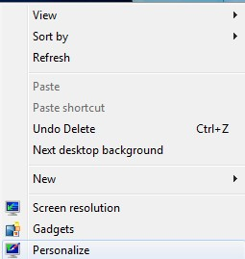

**How to Restore Data**

* right click on recycle bin
* click on open
* search file or folder (that you want to restore)

•

right click on it folder

•

click on restore

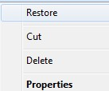

**NOTEPAD**

***What Is Notepad ?***

*Notepad is A Simple Text Editor For Basic Text – Editing Program*

*To Create Document .Notepad Is Developed By Microsoft*

*Corporation It Has Been Part Of Microsoft Windows . A Notepad User Must Write Their Webpage Directly In The HTML . Notepad’s Original Author Is* ***(Richard Brodie)*** *.*

*Notepad Only Accept Text In TEXT Format . So ”.TXT” Extension Name of notepad File.*

***HOW TO OPEN NOTEPAD ?***

### By mouse -

*Go To Start Option >Left Click On Start Option> Go To All Program > Accessories > Notepad*

*By Keyboard - Window Key + R > Type Notepad > Enter*

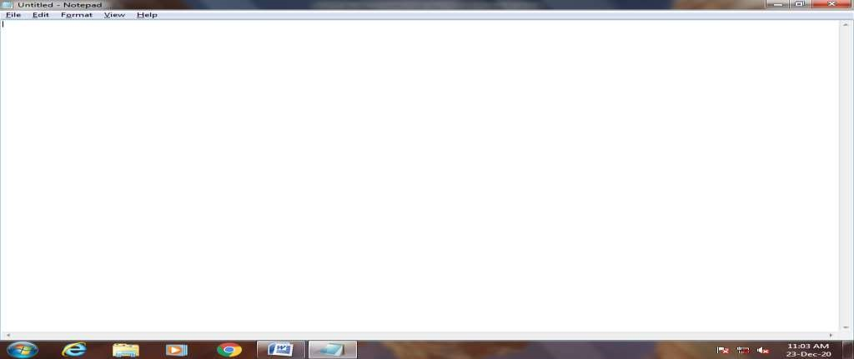

**MINIMIZE SIZE**



**MIXIMIZE SIZE**



**CLOSE FILE**



**MENU BAR**



**TASK BAR**



**STATUS BAR**



**TITLE BAR**

*ALT+SPACEBAR+R > RESTORE (Small Size)*

*ALT+SPACEBAR+X > MAXIMIZE (Big Size)*

*ALT+SPACEBAR+N > MINIMIZE*

*ALT+SPACEBAR+M > MOVE*

*ALT+TAB > RE OPEN*

*ALT + F4 > CLOSE*

**FILE OPTIONS USE**

#### NEW

*Open New Blank File*

*Left Click On File Option > Left Click On New Option*

*Short Key To Open New Blank File In Notepad >* ***Ctrl +N***

#### OPEN

*Open Old Working File in Notepad*

*Left Click On File Option > Left Click On Open Option*

*Short Key To Open Old Working File in Notepad >* ***Ctrl +O***

#### SAVE

*Save Your Current File In Notepad*

*Left Click On File Option > Left Click On Save Option >*

*Put Your File Name*

*Short Key To Save Current Working File To Notepad >****Ctrl +S***

#### SAVE AS

*Rename Your Old File.*

*Left Click On File Option > Left Click On Save As Option >*

*Put Your File Name*

#### PAGE SETUP

*To Set Your Page Size , Page Orientation & Page Margin*

*Left Click On File Option > Left Click On Page Setup Option>*

*To Set Your Page Size , Page Orientation & Page Margin*

#### PRINT

*Print Your Documents*

*Left Click On File Option > Left Click On Print Option >*

*Short Key To Print Your Working File >*

***Ctrl +P***

#### EXIT

*Exit From Notepad*

*Left Click On File Option > Left Click On Exit Option >*

**EDIT OPTION USE**

#### UNDO

*To Move Existing Text/ Formatting*

*(Repeated Last Action)*

*Left Click On Edit Option > Left Click On Undo Option*

*Short key Of Undo >* ***Ctrl +Z***

### Cut

*To Cut Your Text One Place And Paste Your Text Other Places*

*Select your text > Left Click On Edit Option > Left Click*

*On Cut Option*

*Short Key Cut >* **Ctrl+ X**

*Paste > Right Click On Mouse > Left Click On Paste Option*

*Paste > Press* ***Ctrl + V***

#### COPY

*To Copy Your Text*

*Select your text > Left Click On Edit Option > Left Click On Copy Option*

*Short key Of Copy >* ***Ctrl +C***

*Paste > Right Click On Mouse > Left Click On Paste Option*

*Paste > Press* ***Ctrl + V***

#### PASTE

*To Paste Your Text Other Place*

*Left Click On Edit Option > Left Click On Paste Option Short key Of Paste >* ***Ctrl +V***

#### DELETE

*Delete Your Text*

*Select your text >**Left Click On Edit Option > Left Click On Delete Option*

*Short key Of Delete >* ***Ctrl +D***

#### FIND

*Find Any Word And Line Which In Text*

*Left Click On Edit Option > Left Click On Find Option*

*Put Your Find Word) Short key To Find Text >* ***Ctrl +F***

##### REPALCE

*This Is Used To Replace Any Text In Another Text.*

*Left Click On Edit Option > Left Click On Replace Option*

*( Put Your Find And Replaced Word)*

*Short key To Replace Text >* ***Ctrl +H***

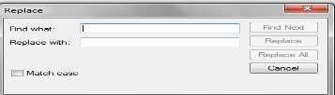

##### GO TO

*This Is Used To Find Any Line Number In File.*

*Left Click On Edit Option > Left Click On Go To Option*

*(Type Line Number In Line Number Box) Short key of Go To >* ***Ctrl +G***

##### SELECT ALL

*Select All Text In Your File*

*Left Click On Edit Option > Left Click On Select All Option*

*Short key >* ***Ctrl +A***

##### DATE /TIME

*To Put Date/Time In Your File.*

*Left Click On Edit Option > Left Click On Date/Time*

*Option*

*Short key >* ***F5*** *(only in notepad)*

## USED FORMATE MENU

### WORD WRAP

*When Word wrap Option Is Untick And Type Any Text*

*In Your File Then That Text Go To Same Line In One Side. And When Word wrap option Is Tick And Type Any Text In Your File then That Text Automatic Go To Next Line.*

### FONT

*To Change Font Style And Size Of Any File.*

*Left Click On Font Option > Left Click To Choose Font Style & Size.*

### USED VIEW MENU

*To Used Hide And Unhide Status Bar Below Text Area.*

#### STATUS BAR

*To Show Line Number And Column Number In Below Of Text Area.*

*Left Click On Menu Option > Left Click Status Bar*

**HELP**

*This option Used To Online help About Notepad.*

# *Wordpad*

*Wordpad is a basic word processor .word pad replaced notepad .wordpad Can use for create and edit file, included text with different fonts & color and insert picture, object to other files . you can be doing By Word pad - letter , notes .*

## *By mouse -*

*Go To Start Option >Left Click On Start Option> Go To*

*All Program > Accessories > Wordpad*

*By Keyboard - Window Key + R > Type Wordpad > Enter*

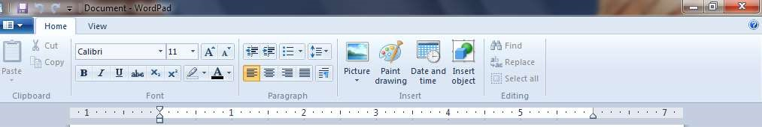

**CLIP BOARD**

**Clip Board**  *- In This option you have given three option - Cut, Copy & Paste.*

## Cut

*To Cut Your Text One Place And Paste Your Text Other Places.*

*Left Click On HOME TAB > Select Your Text > Left Click On Cut Option*

*Short key Of Cut >* ***Ctrl +X***

*Paste > Right Click On Mouse > Left Click On Paste Option Short Key Of Paste >* ***Ctrl + V***

### COPY

*To Copy Your Text*

*Left Click On HOME TAB > Select Your Text > Left Click On Copy Option*

*Short key Of Cut >* ***Ctrl +X***

*Paste > Right Click On Mouse > Left Click On Paste*

*Option*

*Short Key Of Paste >* ***Ctrl + V***

### PASTE

*To Paste Your Text Other Place*

*Left Click On HOME TAB > Left Click On Paste Option*

*Short key Of Paste >* ***Ctrl + V***

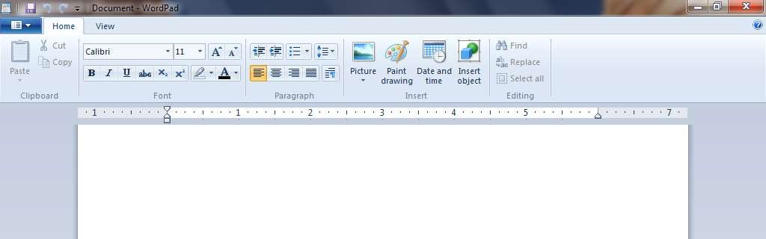

**BOLD**



***ITALI***

***C***



**UNDERLINE**



**STRIKE**

**THOUG**



**SUBSCRIP**



**SUPERSCRIP**



**TEXT**

**HIGHLIGH**



**TEXT**

**COLOR**



**FONT**

**STYLE**



**FONT**

**SIZE**



**GROW FONT**



**SHRINK FONT**

## B(BOLD)

*Format The Selection With Bold. (Bold Your Text)*

*Select Your Text > Left Click On Bold Option*

*Bold By Keyboard >* ***Ctrl +B***

|  |
| --- |
| ***I*** |

## (ITALIC)

*Format The Selection With Italic. (Italic Your Text)*

*Select Your Text > Left Click On Italic Option*

*Italic By Keyboard >* ***Ctrl +I***

## U (UNDERLINE)



*Underline The Selected Text*

*Select Your Text > Left Click On Underline Option.*

*Underline By Keyboard >* ***Ctrl +U***

## ~~abc~~ (STRIKETHROUGHT)



*Draw A Line The Middle Of Selected Text.*

*Select Your Text > Left Click On Strike Option.*

**X2**  **(SUBSCRIPT)**

*Small Later Below The Text Line.*

*Select Your Text > Left Click On Subscript Option.*

*Subscript By Keyboard >* ***Ctrl + =***

|  |
| --- |
| **X2** |

## (SUPERSCRIPT)

*Small Later Above The Text Line.*

*Select Your Text > Left Click On Superscript Option.*

*Superscript By Keyboard >* ***Ctrl + Shift + +***



## (HIGHLIGHT TEXT)

*Text Marked With Light Pen*

*Select Your Text > Left Click On Highlight Text Option.*

## A (TEXT COLOR)



*Change The Text Color*

*Select Your Text > Left Click On Text Option*.

## A (GROW TEXT)



*Increase The Text Size*

*Select Your Text > Left Click On Grow Text Option.*

*Grow Text By Keyboard >* ***Ctrl + Shift + >***

## A (SHRINK FONT)



*Decrease The Text Size*

*Select Your Text > Left Click On Shrink Text Option. Shrink Text By Keyboard >* ***Ctrl + Shift + <***

## (FONTS)

**Calibri**



*Change The Text Face*

*Select Your Text > Left Click For Select Font.*

### 11 (FONT SIZE)



*Change The Font Size*

*Select Your Text > Left Click For Select Font Size.*

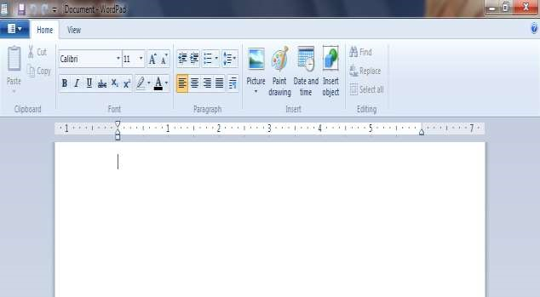

ALIGN TEXT LEFT



CENTER



ALIGN TEXT RIGHT



JUSTIFY



PARAGRAPH



DECREASE INDENT



INCREASE INDENT



START A LIST (BULLET)



LINE SPACING

#### DECREASE INDENT

*Decrease Your Text Right Side In Page*

*Select Your Text > Left Click On Decrease Indent Option.*

#### INCREASE INDENT

*Increase Your Text Left Side In Page*

*Select Your Text > Left Click On Increase Indent Option.*

#### BULLETS

*Add Bullets In Your Text.*

*Select Your Text > Left Click On Bullets Option.*

By keyboard – CTRL+SHIFT+L

#### LINE SPACIN

*Space Between Line Of Text. Add & Remove Space After Paragraph.*

*Select Your Text > Left Click On Line SpacingOption.*

|  |
| --- |
|  |
|  |
|  |
|  |
|  |

#### ALIGN LEFT

*Align Text Left Side.*

*Select Your Text > Left Click On Align Left Option.*

By Keyboard (CTRL+ L)

|  |
| --- |
|  |
|  |
|  |
|  |
|  |

#### CENTER

*Center Your Text*

*Select Your Text > Left Click On Align Center Option.*

By Keyboard (CTRL+ E)

#### RIGHT

*Align Text Right Side.*

*Select Your Text > Left Click On Align Right Option.*

By Keyboard (CTRL+ R)

|  |
| --- |
|  |
|  |
|  |
|  |
|  |

#### JUSTIFY

*Clean Look Along The Right & Left Side Of Page.*

*Select Your Text > Left Click On Align Left Option.*

**P**



#### PARAGRAPH

*Show The Paragraph Dialog Box. Set Your Indention & Spacing Line.*

*Select Your Text > Left Click On Paragraph Option*.

**INSERT GROUP**



#### PICTURE

*To Insert Picture In Word pad Document.*

*Left Click On Picture Option > Select Picture*

*After Open Picture You Can Change & Resize Your Picture.*

#### PAINT DRAWING

*To Insert Your Paint File And Change The Image Size.*

*Left Click On Paint Tab > Draw Your Object >*

*Short key Of Open Paint File >* ***Ctrl +D***

#### DATE & TIME

*Insert Current Date & Time In Your File*

*Left Click On Date/Time Tab > Select Date & Time >*

*Ok*

#### INSERT OBJECT

*To Insert Graph And Text Object Of Microsoft*

*Package*

*Left Click On Insert Object Tab > Select File > Ok*



**EDITING**

#### FIND

*Find Any Word And Line Which In Text*

*Left Click On Find Option( Put Your Find Word)*

*Short key To Find Text >* ***Ctrl +F***

#### REPALCE

*This Is Used To Replace Any Text In Another Text.*

*Left Click On Replace Option ( Put Your Find And*

*Replaced Word)*

*Short key To Find Text >* ***Ctrl +H***

#### SELECT ALL

*Select All Text In Your File*

*Left Click On Edit Option > Left Click On Go To Option Short key >* ***Ctrl +A***

**VIEW TAB**

*Three Group In View Tab.*

1. *Zoom In .*
2. *Show Or Hide.*
3. *Settings.*



#### ZOOM IN

*Zoom In On The Documents*

*Select Text > Left Click On Zoom In*



#### ZOOM OUT

*Zoom Out On The Documents*

*Select Text > Left Click On Zoom Out*

**100%** *Set Your Page In Normal Margin (100%)*

#### RULER

*Hide & Unhide Ruler*

*Left Click On Ruler  Show Ruler Top Of Page.*

#### STATUS BAR

*Hide & Unhide Status Bar*

*Left Click On Status Bar  Show Status Bar Below The Page.*

#### WORDWRAP

*Word wrap – Text Automatically Moved To Next Line. Without Press The Enter Key After Text Line. In This Format You Have Given Three Option.*

* *No Wrap*
* *Wrap To Window*
* *Wrap To Ruler*

#### MEASURMENT UNITS

*Measurement Unit For Ruler And Page Setup.*

*Left Click On Measurement Units  Set Ruler Margin In – Inches, Centimeters , Points & Picas.*

## Microsoft-Paint



Q.1 What is ms-paint ?

Microsoft Paint Is A Simple Raster Graphic Editor That Included All The

Microsoft Windows Versions. The Program Open & Save Files In Bitmap,

PNG, TIFF & JPEG. The Program Can Be In Color Mode Are Two – Color Black & White. Ms Paint Can Be Used To Draw, Color & Edit Picture, import picture From A Digital Camera.

* Develop By – Microsoft Corporation
* Initial Release Date – Nov. 1985
* Operating System – Microsoft Windows

Q.2 How To Start Ms - Paint ?

**By mouse**  = Click On Start Button  All Program  Accessories  Click On Paint

**By Keyboard**  = Press Window Key **+** R  Type mspaint  Ok

When you opened ms- paint. the following paint window will appear on the screen the shown below.

→ Components of ms – paint Maximum Zoom - 800%

* + - Title bar Minimum Zoom - 12.5%
    - menu bar
    - Tool box
    - Color box
    - Status bar
    - Control button
    - Horizontal & vertical bar

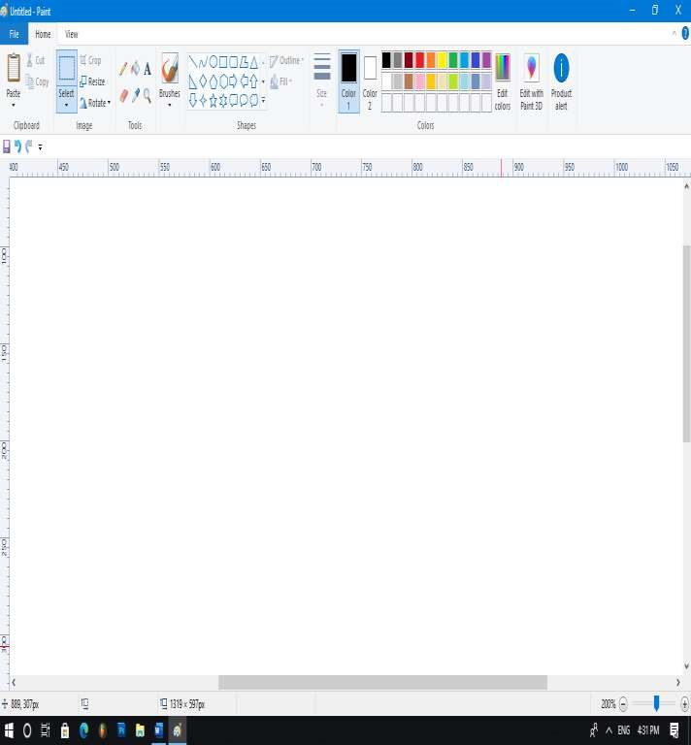

Title bar

Menu

bar

Quick Access Tool Bar

Control Buttons

status

bar

Vertical scroll

Horizontal Scroll

Color boxes

Canvas / Drawing Area

Zoom in &

out

→ If you using window 7 or other advanced operating system, you will find a much more improved in ms-paint program.

For example –3D paint feature included in window 10

**HOME TAB**

Home tab divided in 5 parts. – clipboard, images, tools, shapes & color.

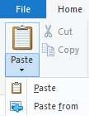

Clipboard

Clipboard is a temporary storage area in the memory which can store image & text. To paste data from clipboard and use the paste command. Four group in clipboard. Cut , copy, paste & paste from.

**Cut -** cut option used to cut any object one place & paste to other place.

* Select any object
* Click on cut option
* After then object gone in clipboard
* Paste other place to cut object

**Copy -** copy option used to copy your object .

* Select any object
* Click on copy option
* After then object gone in clipboard
* Paste other place to copy object

**Paste -** this open used to paste your object

**Paste from -** this option used to paste another file into activate file.

* Click on paste from option
* Paste your object

You can also press **window key + v** To show clipboard history.

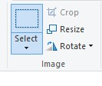

**Images**

In this group you can select drawing, change size of image , rotate & crop drawing. In this group 4 option given. - select , crop, resize & rotate.

**select -** select option used to select your object in rectangular shape.

* Select any object
* Click on select option
* After then you can move & delete your object

You have given also sub options in drop down list in select option. when you click on drop down button. Which given shown below.

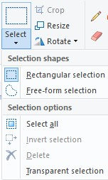

Explanation of all about this sub options 

**Rectangular selection -** this option used to select & crop your object in rectangular shape.

* Click on drop down button
* Click on rectangular selection
* Drag with mouse on any object

**Free from selection -** this option used to select & crop your object in customize shape.

* Click on drop down button • Click on free from selection.
* Draw any customize shape on object

**Select all -** this option used to select all object .(Ctrl+A) **Invert selection -** this option used to selected area nothing move.

**Delete  -** this option used to delete selected part of object.

* Select object with rectangular OR free selection • Click on drop down button
* Click on delete.

**Transparent selection -** this option used to remove background of selected object.

* Select any object
* Click on drop down button
* Tick transparent selection✓

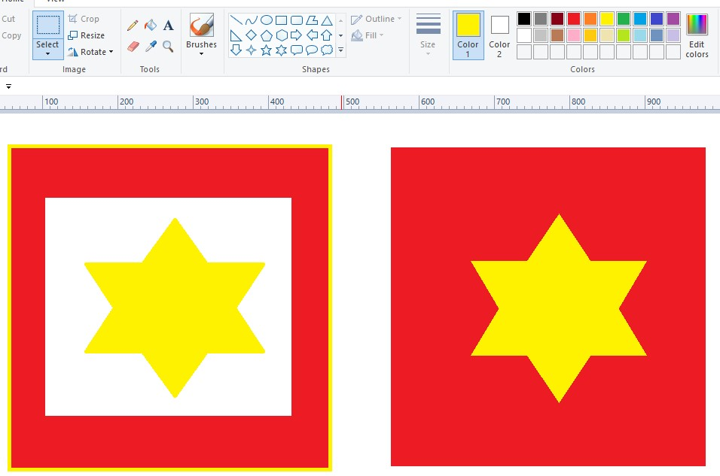

**Transparent selection**

✓



**Untick**

**Transparent selection**

**Crop -** this option used to crop image in various shape.

* Select any object
* Click on crop tool

**Resize -** this option used to change image size in various shape.

* Open image
* Click on resize tool

When you click resize tool a dialog box will appear below 

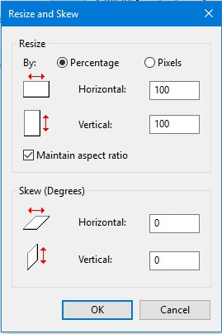

You have given two option – resize & skew.

* You can change image size in horizontal & vertical.
* You can skew image.(degree)

**Rotate -** this option used to rotate image in various various degree

* Open image
* Click on rotate tool

When you click rotate tool a dialog box will appear 

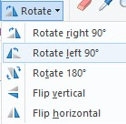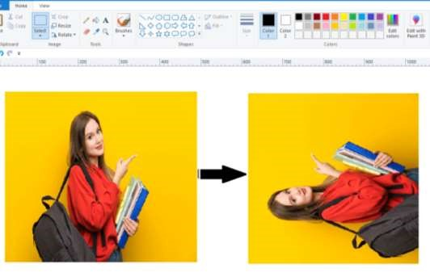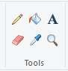

**Tools**

In this option you have given 6 tools.- pencil, fill, text, eraser, color picker & magnifier.

**pencil -** this tool used to draw a free from line .

**fill -** this tool used to fill color in foreground & background.

* Click an area on the canvas to fill it with foreground color , or right click to fill it will the background color.
* Left click for Fill color 1 , right click for fill color 2

**Eraser -** this option used to erase object with left click or you can also used to foreground & background color.

* Click on eraser tool
* Click color 2 (fill other color in color 2)
* right click for color 2 on color 1

note :  you choose different color in foreground & background.

→ object color & color 1 is same then color 2 fill with right click.

→ ctrl **+**  eraser increase

→ ctrl - eraser decrease

**Text -** this tool used to text to be typed in primary color . the text controls in the tool bar can be used the font size, font , formatting, text rendering mode & justification .

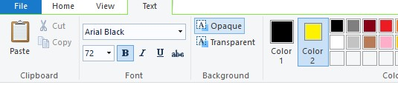

by default the text background is transparent . click on opaque button to show text background button then click on color 2 and pick another color .

* Click on text tool
* Click on canvas
* Typed text
* Click opaque for background & click on transparent for transparent background.

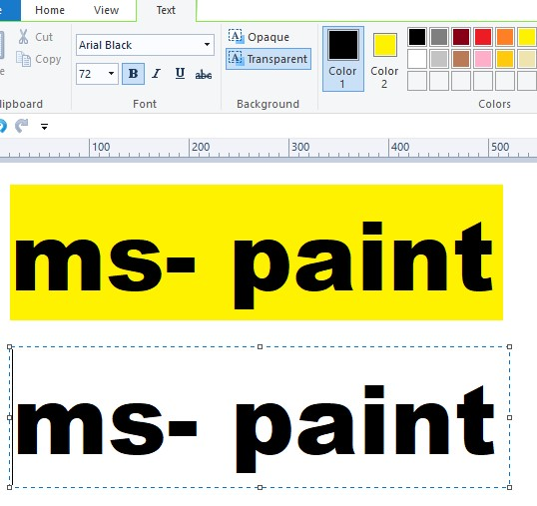

Opaque



Transparent

**Color picker -** this tool used to pick a color from picture and fill in drawing.

* Click on paste from option for open image
* Click on color picker tool
* Pick the color from the image using the color picker tool
* Picker color will be reflected in color 1 .
* Paint bucket selected by itself to fill with the color picker.
* Click on object for fill .

**Magnifier -** this tool used to change the zoom level of working object. click on the images , the zoom is applied to the whole images.

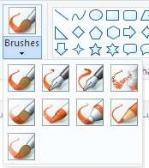

**Brushes**

This option used to different kind of brush tool in drawing. Like – air brush, marker, water color & calligraphy .

Click on drop down button which shown below in brush option.

Choose any brush and change brush size from size option.

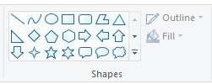

This option used to insert ready made shapes. You have given – line, polygon, curve & six pointer shapes.

Note:

→ Insert a shape with equal sides by holding the “shift” key as you drag pointer.

→ Insert a straight line holding “shift”

→ if you change shape outline color – drag shape  now shape selected itself  after then choose any color in color 1  then outline color changed.

→ outline color change only on color 1.

* Select any shape
* Drag the pointer to draw the shape to the desired size
* You can edit your outline or fill – click outline & fill and change in to “no outline” or change with -marker, crayone, solid & water color.

If you want add a additional color in color boxes – click on edit color option . then edit color palate open.

select any color  click ok

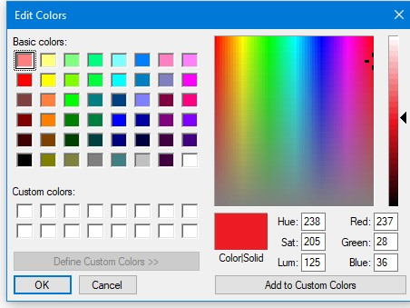

### VIEW TAB

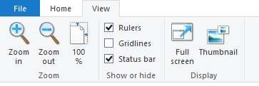

**Zoom in -** this option used to zoom in on the current picture

**Zoom out -** this option used to zoom out on the current picture

**Ruler -** ruler use to line up and measure object in your picture.

**Gridline -** use gridline to align object in your picture.

**Status bar -** this option used to show or hide status bar at the bottom of the window.

**Full screen -** this option used to see full screen view.

**Thumbnail -** this option used to small image represent of a large images.

* Click on zoom in  click on thumbnail  now thumbnail box appear .

**Activity**

* Draw any shape
* Click on select option
* Select the shape
* Click on select option  click on drop down button  tick on transparent selection.
* Holding “ shift”  object move with left pointer.

**How to blur something on paint**

Navigate the image where you wish to add the blur.

* Open image
* Click on rectangle tool
* Single click on the object within the image that you wish to blur
* Drag the transparent rectangle around it.
* Choose color in “color 2”
* Click on fill button located next to the box with the shapes. Choose either of the following options effects – crayon, marker, oil & water color. • Click on outline  click on “ no outline option”.

**How to convert a drawing to a JPEG file**.

Drawing can be easily convert in jpeg file .if you converted jpeg format, it become a picture just like any other. Thus you will able to share the drawing with people who may not be able to open a vision drawing on their computer.

* After you complete drawing click on file tab  click save
* Type the name of drawing in the box marked “file name”.
* In the drop-down box marked save as type  select “jpeg”. • Click on save

**Short key of ms -paint**

|  |  |  |
| --- | --- | --- |
| Crop - | | ctrl+ shift+ x |
| Resize - | | ctrl+ w |
| Increase outline/brushes - | | ctrl + + |
| Decrease outline/brushes - | | crtl +- |
| zoom in | - | page up |
| zoom out | - | page down |
| ruler | - | ctrl + R |
| gridline | - | ctrl + G |
| full screen | - | f 11 |
| increase eraser | - | ctrl + |
| decrease eraser | - | ctrl - |
| remove selection | - | ESC/delete |
| open file menu | - | Alt + f |
| image property | - | image property |
| create new picture | - | ctrl+ N |
| interchange color | - | ctrl+ shift + I |

**MICROSOFT OFFICE WORD**

### (WINWORD)

*Microsoft Word is A Word Processor Develop By Microsoft It Was*

*First Released On Oct. 25, 1983 . In 2007 .Docx (Extention Name)*

*Become The File Format . Microsoft Office Word Help You Produce*

*Professional Looking Document . You Can Create Later , Resume &*

*Office Document .You Can Add A Links ,Insert Picture , Comments & Mailing By Winword*

*How To Open Winword ?*

#### *By mouse -*

*Go To Start Option >Left Click On Start Option> Go To All*

*Program > Microsoft Office > Microsoft Office Word*

*By Keyboard - Window Key + R > Type Winword > Enter*

***HOW TO OPEN PARAGRAPH***

*Press =Rand( ) > Enter*

**HOME TAB**

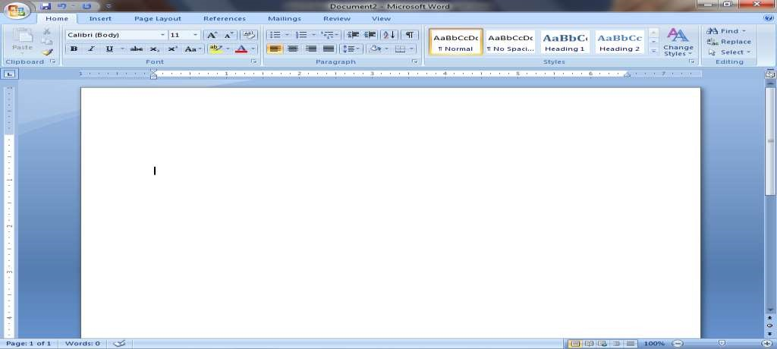

FORMAT PAINTER



COPY



CUT



PASTE

**Clipboard**  *- Four Options In This Group - Cut, Copy , Paste & , Format Painter.*

#### Cut

*To Cut Your Text One Place And Paste Your Text Other Places*

*Left Click On HOME TAB > Select Your Text > Left Click On Cut*

*Option*

*Short key Of Cut >* ***Ctrl +X***

*Paste > Click On Paste Option*

*Paste > Press* ***Ctrl + V***

##### COPY

*To Copy Your Text*

*Left Click On HOME TAB > Select Your Text > Left Click On Copy*

*Option*

*Short key Of Copy >* ***Ctrl +C***

*Paste > Click On Paste Option*

*Paste > Press* ***Ctrl + V***

##### PASTE

*To Paste Your Text Other Place*

*Left Click On HOME TAB > Left Click On*

*Paste Option*

*Short key Of Paste >* ***Ctrl +V***

###### FORMAT PAINTER

*In This Option You Have Copy Format Of Text.*

*Left Click On Home Tab > Select Formated Your Text>*

*Left Click On Format Painter Option > Select Your Text*

*Short key Of Format Painter > Select Formatted Your*

*Text >* ***Ctrl +Shift +C.*** *> Copy Of Formatting*

***Ctrl + Shift + V*** *> Paste Formatting.*

#### (BOLD)

*Format The Selection With Bold. (Bold Your Text)*

*Select Your Text > Left Click On Bold Option*

*Bold By Keyboard >* ***Ctrl +B***

***I***

#### (ITALIC)

*Format The Selection With Italic. (Italic Your Text)*

*Select Your Text > Left Click On Italic Option*

*Italic By Keyboard >* ***Ctrl +I***

#### U (UNDERLINE)



*Underline The Selected Text*

*Select Your Text > Left Click On Underline Option. Underline By Keyboard >* ***Ctrl +U***

#### ~~abc~~ (STRIKETHROUGHT)



*Draw A Line The Middle Of Selected Text.*

*Select Your Text > Left Click On Strike Option.*

**X2**   **(SUBSCRIPT)**

*Small Later Below The Text Line.*

*Select Your Text > Left Click On Subscript Option. Subscript By Keyboard >* ***Ctrl + =***

|  |
| --- |
| **X2** |

#### (SUPERSCRIPT)

*Small Later Above The Text Line.*

*Select Your Text > Left Click On Superscript Option. Superscript By Keyboard >* ***Ctrl + Shift + +***

#### (HIGHLIGHT TEXT)



*Text Marked With Light Pen*

*Select Your Text > Left Click On Highlight Text Option.*

#### A (TEXT COLOR)



*Change The Text Color*

*Select Your Text > Left Click On Text Option*.

#### A (GROW TEXT)



*Increase The Text Size*

*Select Your Text > Left Click On Grow Text Option.*

*Grow Text By Keyboard >* ***Ctrl + Shift + >***

#### A (SHRINK FONT)



*Decrease The Text Size*

*Select Your Text > Left Click On Shrink Text Option. Shrink Text By Keyboard >* ***Ctrl + Shift + <***

#### Calibri (FONTS)



*Change The Text Face*

*Select Your Text > Left Click For Select Font.*

##### 11 (FONT SIZE)



*Change The Font Size*

*Select Your Text > Left Click For Select Font Size.*

**Aa (change cases)**



*This Option Used On Text. Change All The Text In Lower , Upper , Toggle Cases. Change Cases Are 5 Types.*

1. ***Sentence Case :*** *This Option Used To First*

*Word In Capital Of Text.*

1. ***Lower Case*** *: This Option Used To All*

*Word**In Small Later.*

1. ***Upper Case :*** *This Option Used To All Word*

*In Capital Letter.*

1. ***Capital Each Word :*** *This Option Used To Capital*

*Each Word.*

1. ***tOGGle*** *: This Option Used To First Word In Small Later.*

*Select Your Text > Left Click On Change Cases > Select Any Cases. That You Want.*

*Short key Of Change Cases. Shift + F3*



**Aa**



**(CLEAR FORMATING)**

*Clear Formatting In Text Without Leaving Plain Text.*

*Select Your Text > Left Click On Clear Formatting Option.*



**BULLETS** *Add Bullets In Your Text.*

*Select Your Text > Left Click On Bullets Option.> Select*

*Any Bullet > ok*



**1**

**2**

**3**

**(NUMBRING )** *Text Start With Numbers.*

*Select Your Text > Left Click On Numbering Option &*

*Select Numbers*.

**1**

**a**



**i**

#### (MULTILEVEL LIST)

*Text Start With Multilevel List.*

*Select Your Text > Left Click On Multilevel List Option & Select List.*



##### DECREASE INDENT

*Decrease Your Text Right Side In Page*

*Select Your Text > Left Click On Decrease Indent Option.*



##### INCREASE INDENT

*Increase Your Text Left Side In Page*

*Select Your Text > Left Click On Increase Indent*

*Option.*



A

Z

##### (SORT)

*Alphabetized The Selected Text Or Sort Numerical Data.*

*Select Your Text > Left Click On Sort Option. (Select Ascending & Descending).*

**(SHOW PARAGRAPH MARK)**



*Show Paragraph Mark And Other Hidden Formatting*

*Symbol.*

*Select Your Text > Left Click On Paragraph Mark Option.*

*Paragraph Mark By Keyboard. =* ***Ctrl + Shift + 8***

##### ALIGN LEFT

*Align Text Left Side.*

*Select Your Text > Left Click On Align Left Option.*

|  |
| --- |
|  |
|  |
|  |
|

##### CENTER

*Center Your Text*

*Select Your Text > Left Click On Align Center Option.*

|  |
| --- |
|  |
|  |
|  |

*Align Text Right Side*

##### RIGHT

*Select Your Text > Left Click On Align Right Option.*

##### JUSTIFY

*Clean Look Along The Right & Left Side Of Page.*

*Select Your Text > Left Click On Align Left Option.*

*Space Between Line Of Text. Add & Remove Space*

LINE SPACIN *After Paragraph.*

*Select Your Text > Left Click On Line Spacing Option*

*Color The Background Behind The Selected Text*

##### (SHADING)

*Select Your Text > Left Click On Shading Option > Select Color.*



##### (BORDER)

*Insert Border In Selected Text.*

*Select Your Text > Left Click On Shading Option > Select Color.*

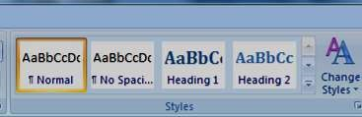

##### (CHANGE STYLE)

*In This Option You Can Change The Set Of Style , Color , Font & Text Change In To Headings. (Heading 1 , Heading 2 ).*

**(**

**EDITING**

**)**

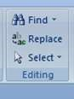

*In This Dialog Box You Have Given 3 Option. (Find , Replace , Select ).*

***FIND =***  *Find Any Word And Any Line .*

*Left Click On Edit Option > Left Click On Find*

*Option Put Your Find Word.*

*Short key To Find Text >* ***Ctrl +F***

***Replace =*** *This Is Used To Replace Any Text In Another*

*Text.*

*Left Click On Edit Option > Left Click On*

*Replace Option ( Put Your Find And Replaced*

*Word)*

*Short key To Find Text > Ctrl +H*

***Select =***  *This Option Used To Select All , Select Object ,*

*Select Text With Similar**Formatting .*

**INSERT TAB**

*This Tab Has A Lot Use full Features That Will Let You Insert Thing Like - Picture , Clip Art , Images , Shapes , Smart Graphics , Chart & Lot Of Other Items.*

*In This Dialog Box You Have Given Three Option -*

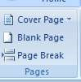

*Cover Page , Blank Page , Page Break*

***COVER PAGE***

*Insert A Formatted Cover Page. Cover Page Always*

*Insert The Beginning Of The Document . After You*

*Insert A Cove Page . It Will Replace First Cover Page. (You Fill The Tittle , Author , Date And Other.)*

*On The Insert Left Click On Cover Page Layout Of Options.*

***BLANK PAGE -*** *Insert A New Blank Page In Your Document.*

***PAGE BREAK*** *- This Option Help To Break The Page In To Parts In Current Position. We Can Use Short Key Of Page Break.* ***Ctrl + Enter.***

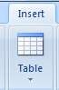

*In This Option You Have Insert Or Draw A Table In Your Document. In This You Have Given Many Groups Related To Table Option.*

*Left Click On Table Option For Insert Table*.

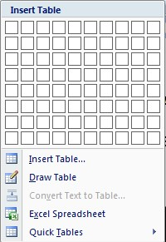

*In This Dialog Box You Can See in Dialog Box You Can Create Basic Table.*

*Left Click On Insert Tab > Left Click On Table*

*Option > Curser Over The Grids Until .Row &*

*. Column That You Want*

***INSERT TABLE***  **-** *In This Option You Have Insert & Row And*

*Column Number That You Want*

***DRAW TABLE*** *- In This Option You Have Draw A Table.*

***CONVERT TEXT TO TABLE***  **-** *In This Option You Have Convert A Text In*

*To Table.*

***EXCEL SPREAD SHEET -*** *In This Option You Have Insert A Microsoft*

*Excel Worksheet.*

***QUICK TABLE* *-*** *Insert Calendar*

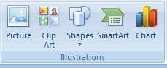

***PICTURE*** *- Insert A Picture In File.*

*Left Click On Picture Option > Select Picture > Click On Insert.*

***CLIP ART -*** *Clip Art In To Document Including Drawing , Movies , Sound .*

*Left Click On Clip Art Option > Search Any Picture > Click On Picture For Insert This Picture in document.*

***SHAPES*** *- Insert A Shape In File Like - Rectangular , Circle Arrow , Lines , & Flow Chart Symbols.*

*Left Click On Shapes Option > Select Any Shape .*

*Click The Shape That You Want To Apply*

*Different Style*.

***SMART ART*** *- Insert A Smart Art Graphic To Visually Communication.*

*Left Click On Smart Art Option > Select Any Graphic*

***CHART*** *- Insert Chart In File And Compare Data - Left Click On chart Option > Select Any Chart .*

*Click The format menu That You Want To Apply Different Style* .

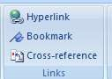

***Hyperlink -*** *Create A Link On Web Page Or File A Picture , E –*

*Mail Address & Other Program. Hyperlink is most commonly used tool in internet. You can create link in specified location in file that are saved in ms – office*

*Left Click On hyperlink Option > Select the Picture or text that you want to displayed as a link > Left Click On ok*

*Short key of Hyperlink =* ***CTRL + K***

*Click with CTRL for open linked file in your current file.*

***BOOKMARK*** *- Create A Bookmark To Assign A Name To Specific Point In A Document. That You Find Again Easily.*

*Click The Line That You Want To Add A Bookmark*

*> Left Click On Bookmark Option > Insert Any Name > Click On ADD*

##### *For Open Added Bookmark -*

*Left Click On Bookmark Option > Select Bookmark Name > Click On Go To .*

***NOTE*** *- Bookmark Names To Begin With A Letter*

*.They Can Include Both Number And*

*Letter But Not Space.*

***CROSS- REFRENCE-*** *Refer To Item Like – Heading , Table & Figure*

*By Inserting A Cross–Reference. cross – Reference Are Automatically Update If Content Is Moved To Another Location.*

***1.*** *In The Document Type The Text That Begins The Cross -Reference*

*Like – Figure 1 , Figure 2 , Heading 1 Heading 2*

1. *Click Insert Tab*
2. *Click On Cross –Reference.*
3. *Reference Box Opened Then Click The Dropdown List To Pick What You Want To Link*

*To.*

1. *Click Each Heading / Figure/Table/ That You Want To Link In Page. > After Then Click On Insert That Show In Bottom Of Refrence Box.*
2. *Click With CTRL Each Items.(Refrence Allow To Jump The Refrence Items.*

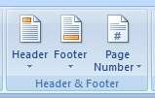

**Header**  *- Edit The Header Of The Document. You Can*

*Make Your Document Professional By Using This Section. Header show In top of page.*

* 1. *Left click on insert tab*
  2. *Left click on header*
  3. *Select any header style*

*You can also edit header. if you want to remove header click On remove header option that show in header box.*

**Footer -** *Edit The footer Of The Document .You Can Make*

*Your Document Professional By Using This Section. Footer show In bottom of page.*

* 1. *Left click on insert tab*
  2. *Left click on footer*
  3. *Select any footer style*

*You can also edit footer. if you want to remove footer click On remove footer option that show in footer box.*

**Page Number -** *Insert A Page Number In Document. In top , in*

*bottom , In margin . you can also change page number formatting.*

*Left click on insert tab > click on page number option > select Any page number style.*

*.*

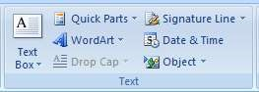

**TEXT BOX** *- - Insert A Formatted Text Box. Text Box Let You*

*Being Focus To Specific Text . You Can Choose From Varity Format Text Box Or Draw And Format You Own.*

*Left Click On Insert Tab > Click On Text Box Option > Select Any Text Box.*

**WORD ART** *- Insert Decorated Text In Your Document ..*

*Left Click On Insert Tab > Click On Text Word Art Option > Select Any Format That You Want.*

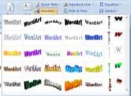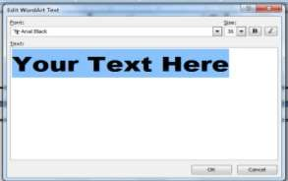

*Enter any text in dialog box > click ok. You can apply different style in your text by format option.*

**Drop cap -** *drop cap option used to a large letter Can be used to begin a chapter or to add a newsletter. In this option you have given three option. - drop & In – margin drop cap.*

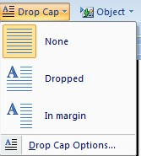

*Select paragraph > Left Click On Insert Tab > Click On drop cap or margin drop cap Option*

**Signature line**  *- insert a signature line that the specific the individual Who must sign. this option used to digital signature .Insert in document .*

##### *Click the curser that you want to insert*

*signature Left Click On Insert Tab > Click On signature line option > click on Microsoft office Signature line > ok >*

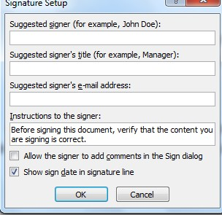

*Enter Your Name Or Title > Ok*

**Date & Time** *- insert current date & time in current document . Left click on insert tab > click on date & time option > Select any date & time > ok.*

**Object**  *- insert an embed object . Microsoft allow you to embed Object create in other program in to one document.*

*For example – you can use excel spread sheet.*

*Left click on insert tab > click on object option > select Application that you want insert .*

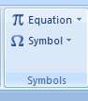

**Equaction** *- insert mathematical commas , equations or build*

*up Your equation. Using a library of math symbol .*

*you Also insert new equations .*

*left click on insert tab > click on equation option > select equations .*

*(you can also change equations format like - in liner*

*, in Professional , change in to line , justification )*

**Symbols** *- insert symbols that are not on your keyboard* *such as copyrighter , trademark symbol , paragraph mark .*

*Left click on insert tab > select any symbol .*

# PAGE LAYOUT TAB

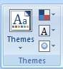

**THEMES** *- Change The Over all Design Of entire Document*

*Including Colors , Fonts & Effects .*

*Left Click On Page Layout Tab > Click On Theme Option > Select Any Theme.*

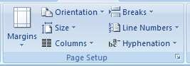

**Margine** *- Select The Margin Size For The entire Document . Or*

*The Current section. You Can Default Page Margin Or You Can Specify Your Own In Custom Margin .*

*Left Click On Page Layout Tab > Click On Margin*

*Option > Select Any Margin That You Want .*

*(Your Entire Document Automatically Change To Be Margin)*

*For Most Commonly use Margin Width – Click Normal Margin .*

**Oriantation.** *- In This Option You Can Choose Either Portrait & Landscape Orientation For All Or Part Of Document.*

*Left Click On Page Layout Tab > Click On Orientation Option > Select Portrait Or Landscape That You*

*Want.*

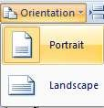

**Size** *- Choose The Page Size For The Current Section. To*

*Apply A Specific Paper Size To All Document Click More Paper Size.*

*Left Click On Page Layout Tab > Click On Size Option >*

*Select Any Size That You Want.*

**COLUMNS** *- Split Your Text In Two Or More Columns In Your*

*Text.*

*Left Click On Page Layout Tab > Click On Columns Option > Select Any Column split That You Want.*

**BREAK**  *- Add Page , Section , Column Breaks To The*

*Document.*

*Left Click On Page Layout Tab > Click On Break Option > Select Any Option That You Want.*

**Line Numbers** *- Add A Line Number In Margin Each Line Of The*

*Document.*

*Left Click On Page Layout Tab > Click On Line Number Option > Select Any Format Of Lines That You Want.*

**Hyphenation** *- This Option Allows Word To Break Lin Between*

*The Syllables Word. If Word Is Too Long To Fit*

*At The End Of Line You Can The Word To The Beginning Of The Next Line Instead . By Using The Hyphenation Feature.*

*Select Text > Left Click On Page Layout Tab > Click On Hyphenation Option > Click On Automatic.*

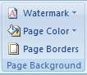

**Watermark** *- Insert A Ghosted Text In Behind The Content On The*

*Page . this option used to indicate that a document Is to treated specially. You can added picture or text Watermark.*

1. *Click on page layout tab*
2. *Click on watermark option*
3. *Click on custom watermark*
4. *Click the radio button for text watermark*

*5.Put your text ( you can also change font , size , color & layout)*

*6.Click on ok*

**Page color** *- Select a Color From The Background Of The Page.*

1. *Click on page layout tab*
2. *Click on page color option*
3. *Select any color(you can also fill effect in page)*

**Page Border** *- Insert Or Add A Border Around The Page.*

1. *Click on page layout tab*
2. *Click on page border option*
3. *Select any border (you can also insert a art border. Click on art border)*

*4.*

*Click on ok.*

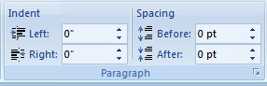

**Indent** *- move in the left side of paragraph by a certain amount.*

1. *Click on page layout tab*
2. *Click on indent option*
3. *Click on right & left option that you want.*

**Spacing** *- Change The Spacing Between Paragraph By Adding*

*Space above the selected paragraph.*

1. *Click on page layout tab*
2. *Click on spacing option*
3. *Click on after and before option that you want.*

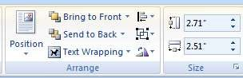

**Position** *- Position The Selected Object On The Page . Text Is*

*Automatically set to wrap around the object .*

* 1. *Insert any picture or shape*
  2. *Click on picture or shape*
  3. *Click on position option*
  4. *Select any position that you want.*

**Bring To Font -** *Bring The Selected Object In Font Of all Other*

*Object no part of it is hidden behind another object.*

**Send To Back** – *Send The Selected Object Behind All Other Object.*

**Text Wrapping** *- Change The Way Text Wrap Of All Selected*

*Object*

* 1. *Insert any picture or shape*
  2. *Click on picture or shape*
  3. *Click on text wrapping*
  4. *Select any option that you want.*

**ALIGN** *: Align The Edge Of Multiple Selected Objected.*

*You Can Also Center Them , Distribute Them.*

* 1. *Insert any multiple picture or shape*
  2. *Click on multiple picture or shape*
  3. *Click on align option*
  4. *Select any option that you want.*

**Group**  *- Group The Object Together So That They Can Be*

*Treated like a single object.*

* 1. *Insert any multiple picture or shape*
  2. *Click on multiple picture or shape*
  3. *Click on group option*
  4. *Click group (your object has been changed a single object)*

* 1. *If you want to ungroup or regroup your object so click on ungroup or regroup option.*

**Rotate -** *Rotate Or Flip The Object.*

* 1. *Insert any picture or shape*
  2. *Click on picture or shape*
  3. *Click on rotate option*
  4. *Click on any option that you want .*

***References***

*The Reference Tab Offered A Quick Way To Enter Your Document*

*Sources , Citation And Choose Any Style On The Reference Tab You Will Find Things Like Content , Footnote , Bibliography , Table Of Figure , Caption & Index .*

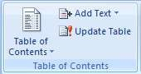

*Add A Table Of Content To The Document .*

1. *Insert A Headings In Each Pages.*
2. *Insert Blank Page In Top Of Headings.*
3. *Move The Cursor On Blank Page And Click On Table Of Content.*
4. *Select Any Content.*
5. *If You Want To Add Other Heading And Update In Table Of Content So Create New Heading Then*
6. *Click On Add Text On Level 1 , 2 , 3 Any One.*
7. *Select Content*
8. *Click On Update Table 9. Click On Entire Table*

*10. Click On Ok.*

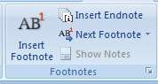

*Footnote are automatically renumbered as you move text around the Document . in this option used to insert footnote to the document.*

*Footnote added in always end of paragraph . & endnote always added in bottom of page.*

1. *Click where you want to reference to the footnote or endnote.*
2. *Click reference tab & click insert footnote option.*
3. *Footnote or endnote are show in numbering*
4. *If you want to return to your place in document you can use “Next endnote” options .*
5. *If you want to move your curser on footnote & endnote you*

*Can use “show note” option.*

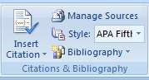

*Insert citation option used to be cite a book , journal article , and other periodical as there sources of a piece of information in the document . you have to be choose the list of sources you have created information.*

* 1. *Click on insert citation option.*
  2. *Click on added new sources option. & fill detail. > ok*
  3. *Click on Bibliography option. & select any Bibliography Style.*

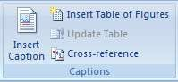

*Add A caption Of picture or other image.*

*1. Click on insert caption option. Select any label > ok 2. Insert image each pages. (information about image)*

* 1. *Insert Blank Page .*
  2. *Click on insert table of figure option > ok .*
  3. *If You Want To Add Other caption And Update In Table Of figure click on insert caption > ok*
  4. *insert image (information about image )*
  5. *Select content*
  6. *Click On Update Table*
  7. *Click On Entire Table*
  8. *Click On Ok.*

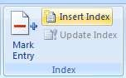

*Include The Selected Text In The Index Of The Document. Index List The Term And Topics That Are Discussed In A Document .*

* + 1. *Select any word in text file.*
    2. *Click on mark entry option . > click on mark .(for mark word).*
    3. *Click on insert index option if you want that selected word show in index > ok*
    4. *If you want to update other word so - Select other word in text file. And mark .*
    5. *Select index*
    6. *Click on update index .*

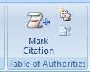

*Insert The Selected Text As An Entry In The Table Of Authority .*

* + 1. *Select word in text file.*
    2. *Click on mark citation option > click on mark .*

*(selected word show in index )*

* + 1. *Click on insert table authority option if you want that selected word show in index > ok*
    2. *If you want to update other word so - Select other word in text file. And mark .Select other word in text file .*
    3. *Select index.*
    4. *Click on update index .*

**Mailings**

*Mailings option is most used to print or E- mail form letter to multiple recipients you can easily customize form letter for individual recipients you can also mail merge used to Create Envelopes .*

*1. Click On select recipient option 2. Click on type a new list option .*

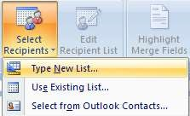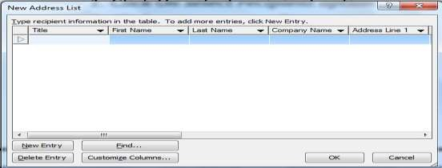

*Click on customize column*

* + - 1. *Click each field > click delete > click yes . (for delete field )(short key of delete field is DYD)*
      2. *Click on add (for create new field ) > type any field > click on add > click on ok*
      3. *Insert information in field. > click ok. > save this file .*
      4. *Click on insert merge field option & insert all field in your letter .*
      5. *Click on greeting line option > ok*
      6. *Type your letter that you want to send your recipient.*
      7. *Click on preview result option*
      8. *Click on auto check error > click on complete merge option .*

*If you increase a recipients list so > click on edit recipient option > click on your file > click on edit.*

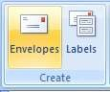

*Envelopes option is commonly used to create & print envelopes .*

* + - 1. *Click on envelopes options*
      2. *Fill delivery address & return address 3. Click on add to document option .*

# Review

*Review tab has got some important command that you can modify your document you can use it adding or removing comments and tracking change including insertion , deletion & formatting .*

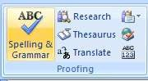

**Spelling & grammar**  *- this option used to check spelling & grammar In your text .*

*check spelling & grammar by keyboard -* F7

**Research** *- Research Option Used To Research The Task Pane*

*That Is Used To Search Reference Material*

*Such As Dictionaries And Translation Services*

**Translate** *- This Option Uses To Translate Selected Text. In To*

*Different Language.*

**Word Counter**  *- This Option Used To Find The Number Of Word*

*In – Lines , Words , Characters .Word Count Also Find On The Status Bar At The Button.*

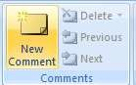

*This Section Used To Add A Comment About The Selection .*

***New comment*** *- this option used to add a comment about the part has been selected .*

*Select text > click on new comment option. > type your comment .*

***DELETE***  *- This Option Used To Delete A Selected Comment.*

***PREVIOUS*** *- Navigate The Previous Comment In The Document*

*.*

***NEXT*** *- Navigate The Next Comment In The Document*

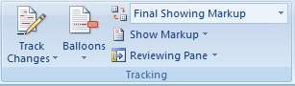

**Track Changes**  *- This Option Used To Tracks change To The*

*Document .*

*Click On Tracking Change Option > Click On*

*Track Change Option > Select Color > OK*

*Or text highlight when you add text after comment.*

***BALLOONS*** *- This Option Use To Help Choose How To Show Revision To The Documents. They Are Two Ways Of Showing .*

1. *Show Revision In Balloons*
2. *Show Revision In Line*

***Reviewing Pane***  *- This Option Used To Help Show Revision In A*

*Separate Window. You Can Use Either The Horizontal & Vertical .*

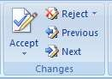

*This Option Help To Access Other Option Such As Accepting all Changes In Document .*

**Accepting**  *- This Option Use To Accept , Change Comment &*

*Move To Next Comment .*

**Reject -** *This Option Use To Reject The Current Comment Document . And Move To Next Changes.*

**Previous -** *Navigate The Previous Comment In The Document*

*.*

*That You Can Accept & Reject It .*

**Next -** *Navigate The Next Comment In The Document . That You Can Accept & Reject It .*

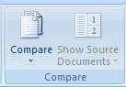

*Compare Or Combine To Multiple Documents.*

* *Click On Compare Option*

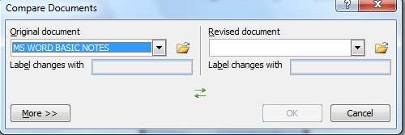

* *Select Different File Each Index*

***Show Sources Document*** *- This Option Used To Show The*

*Original , Revised Documents & Both.*

* *Click On Show Sources Option*
* *Click Any One That You Want .(Original , Revised)*

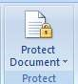

*This Option Used To How To People Can Access The Document .*

* *Click On Protect Documents*
* *Click On Restrict & Formatting*
* *Tick On This Option*

▪

*Click On “Yes”*

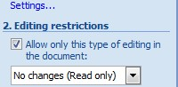

* *Enter Your Password*
* *Ok*

*If You Want Remove Protection In Your Document*

* *Click On Stop Protection Option*
* *Enter Your Previous Password*
* *Ok*

# *VIEW*

**Print Layout** *View The Documents As It Will Appear On The*

*Printed Page.*

*Click On Print Layout Option.*

**Full Screen Reading**  *- View The Reading Full Document Reading .*

*Click On Full Screen Option.*

**WEB LAYOUT** *- View The Document As It Like Web Page*

*Click On Full Web Layout Option.*

**DRAFT**  *View The Document As A draft Quickly Edit To*

*Text .*

*Click On Full Draft Option.*

**RULER**  *Ruler Is Used To Measure Line Up Object In The*

*Document.*

**DOCUMENT MAP** *Open The Document Map That Show Headings*

**GRIDLINES**  *Turn To Gridline That You Can Align Object**In Document .*

**THUMBNAILS**  *which you can use navigate a long document through**small picture of each page.*

*Open A Zoom Dialog Box To Specify The Zoom Level Of The*



*Documents*

* *Click On Zoom Option > Open Dialog Box.*
* *Zoom Your Page That You Want (75 % ,100 % ,200 %)*

*Set Your Page In Normal Margin (100%)*

**100%** *Click On This Option*

**ONE PAGE** *Zoom The Documents So That An Entire Pages Fits*

*In The Windows*

**Two Pages** *Zoom The Documents So That An Two Pages Fits In*

*The Windows*

**Page Width** *Zoom The Documents So That The Width Of The Page Match The Width Of The Window .*

**NEW WINDOW**  *Open A New Window Containing A View Current*

*Document .*

**ARRANGE ALL** *Arrange All Open Program Window Side by*

*Side on screen*

**SPILT** *split the current window in two parts so that You can view different section of the document At the same time .*

**View side by side -**  *view two parts side by side so that*

*You can compare their content*

**Switch window**  *- switch to a different currently open window .*

***Macros*** *click here to record or to access other macro point . You Can Run Create & Delete Macro.*

*Short key of macro -* ***ALT + F8***

*Click On Macro Option*

*Click Record Macro*

*Click On Keyboard Option*

*Create Any Key*

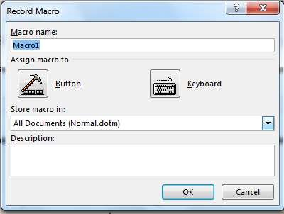

*Click On Assign > OK*

*Create Any Activity*

*You Can Stop Recording & Check Preview . If You Want.*

*Click On Macro Option > Click On Stop*

*Stop Recording > Press Created Key*

**Short keys**

|  |  |
| --- | --- |
| *Ctrl + A* | *Select All* |
| *Ctrl + B* | *Bold* |
| *Ctrl + C* | *Copy* |
| *Ctrl + D* | *Duplicate* |
| *Ctrl + E* | *Align Center* |
| *Ctrl + F* | *Find* |
| *Ctrl + G* | *Go To Any Line* |
| *Ctrl + H* | *Replace* |
| *Ctrl + I* | *Italic* |
| *Ctrl + J* | *Justify* |
| *Ctrl + K* | *Hyperlink* |
| *Ctrl + L* | *Align Left* |
| *Ctrl + M* | *Text Move* |
| *Ctrl + N* | *New* |
| *Ctrl + O* | *Open New Window* |
| *Ctrl + P* | *Print* |
| *Ctrl + S* | *Save* |
| *Ctrl + Shift + D* | *Double Under Line* |
| *Ctrl + U* | *Underline* |
| *Ctrl + V* | *Paste* |
| *Ctrl + W* | *Close Document* |
| *Ctrl + X* | *Cut* |
| *CTRL + Y* | *Redo* |
| *Ctrl + Z* | *Undo* |
| *Shift +F3* | *Text Change Case* |
| *Ctrl + Alt +1* | *Text Change To Heading* |
| *Ctrl+F2* | *Print Preview* |
| *Ctrl+ Shift +C* | *Copy Formatting* |
| *Ctrl+ Shift +V* | *Paste Formatting* |
| *Ctrl +Shift+ F* | *Change Font* |
| *Ctrl +Shift + P* | *Change Font Size* |
| *Ctrl + Shift +>* | *Increase Font* |
| *Ctrl +Shift + <* | *Decrease Font* |
| *Ctrl + =* | *Subscript* |
| *Ctrl + Shift + +* | *Superscript* |
| *Ctrl + Shift + \** | *Paragraph Mark* |
| *Ctrl + Enter* | *Page Break* |
| *F7* | *Check Spelling Grammar* |
| *Ctrl +Shift +E* | *Track Change Of Comments* |
| *Alt +Ctrl +F* | *Insert Footnote* |
| *Alt +Ctrl +D* | *Insert Endnote* |
| *Alt + Ctrl + S* | *Split A Window* |
| *Ctrl + Alt + V* | *Paste Special* |
| *Alt +Ctrl +O* | *Outline View* |
| *Alt +Shift +X* | *Mark Entry* |
| *Alt+ Shift +I* | *Mark Citation* |
| *Ctrl + Home* | *Beginning Of The Document* |
| *Ctrl + End* | *Move To The End Of Document* |
| *Shift + F5* | *Move To Last Point You Were*  *Editing Before Close The Document* |
| *Backspace* | *Delete Text To Left* |
| *Ctrl + Backspace* | *Delete One Word To Left* |
| *Delete* | *Delete The Text To Right* |
| *Ctrl + Delete* | *Delete One Word To Right* |
| *Ctrl+1* | *Set Single Spacing* |
| *Ctrl+2* | *Set Double Spacing* |
| *Ctrl+5* | *Set 1.5 Line Spacing* |
| *Ctrl + 0* | *Remove one Line Spacing* |

**Powerpoint**

**1. What is Powerpoint ?**

Powerpoint(PPT) Is A Powerful Presentation Graphic Software Program That Allows You

To Create Professional Looking Electronic presentation Slide. It Most Often Used To Business & School Presentation. Powerpoint Created By Robert Gaskin And Dennis Austin. It was released on 20 April ,1987.

**Getting stated power point 2007 :**

**Click start button on taskbar**  click all programs  click on Microsoft office Click on Microsoft office powerpoint 2007.

**By keyboard** press window key + R > type powerpnt > ok

The following powerpoint window will appear on the screen as shown below

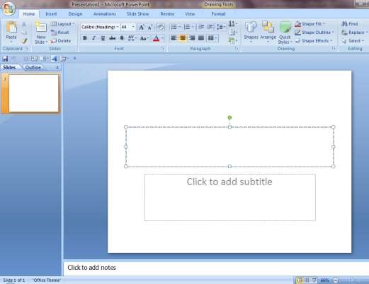

**Place**

**holder**

**Note pane**

**View buttons**

**Slide tab**

**Outline Slide tab**

**Slide view**

## Design & layout theme

* Microsoft office powerpoint 2007 offers to different ways to create new presentation. you can choose from any of the following method, depending on your needs.
* Blank presentation – to create customized presentation.
* Installed presentation – to create presentation using a design new presentation.

A theme is a predefined combination of colors, fonts and effect can be applied to your presentation. Each has additional background styles associate with it can be applied to the slide to modify them

**To Apply Theme :**

* Select design tab
* Located the theme group . each image represent a theme
* Click on drop-down arrow to access more them.
* Click any theme to apply it to the slides. 

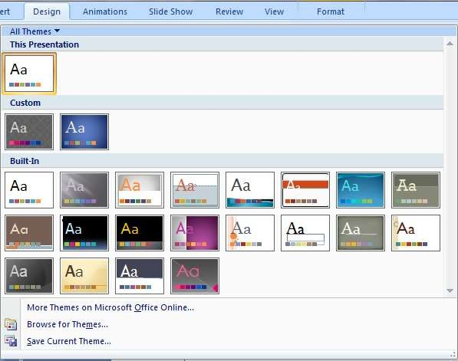

* You can additional theme on Microsoft office online or create own.

Font that are change with the font size and style menu will not change when you apply a new theme.

**Apply background style**  **:**

Background style can be appeared to your slide after a theme applied .the style are fill variation based on theme color. the colors are different based on the theme colors.

* Click on background style 
* You can select format background from the menu to open a dialog box and make change to the background color.

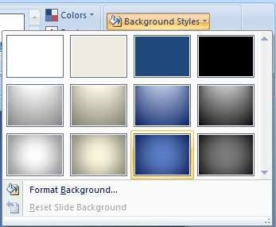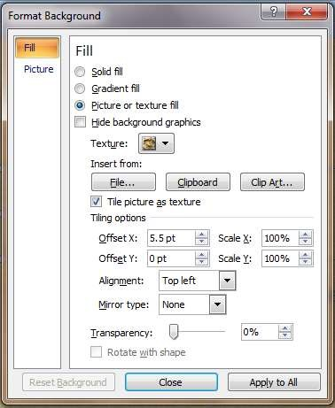

How to change the slide size

You can easily change size of slide in ppt .

* Click On The Insert Tab.
* Click on page setup. A dialog box will be appear.
* To Change The Accept Ratio.

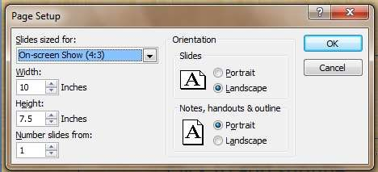

## Animation tab

On the animation tab the advance pane. It can help make presentation more dynamic. type & duration of animation effects applied to text or object on a slide. The most common types of animation affects included entrance and exits. You can added sound to increase the intensity of your animation effects.

* Click on animation tab

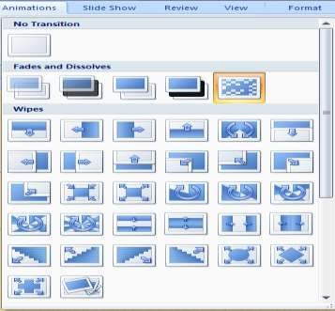

* Click on drop down list .you have given many Animations.

We will create a Text presentation. We will present “step of open Notepad” with Animations.



* + Click on design tab
  + Click on background style option & apply any style on page.

▪

select text box Insert your text

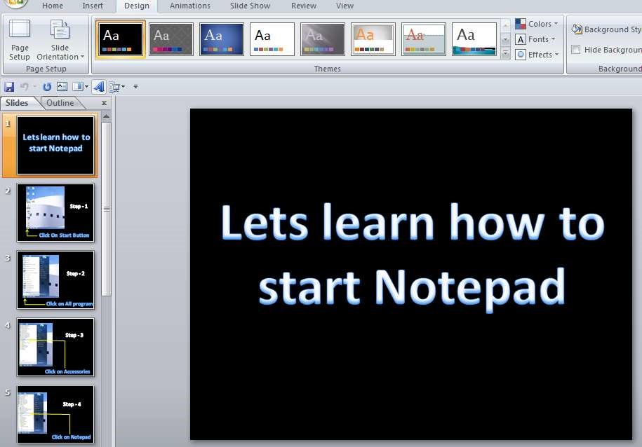

* + Right click on home tab
  + Click on new slide
  + Click blank slide (CTRL+ M)
  + Click on text box & insert your text.

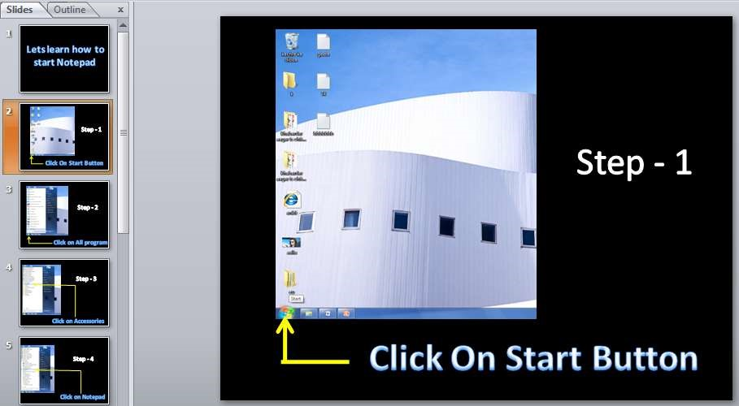

* + Press CTRL + M (new slide)

▪

Click on text box & insert your text.

▪

Press CTRL + M (new slide)

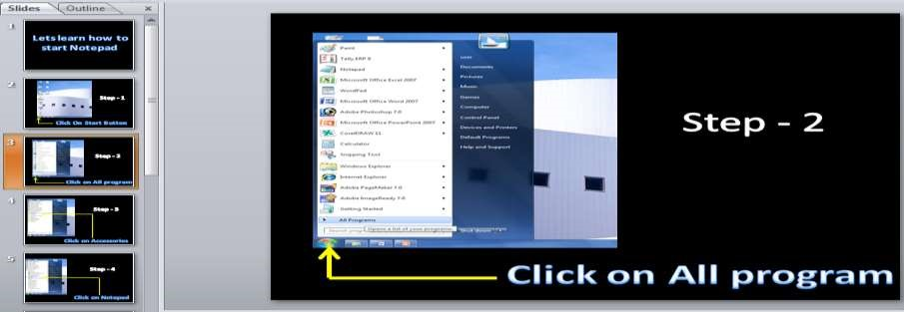

* + Click on text box & insert your text

.

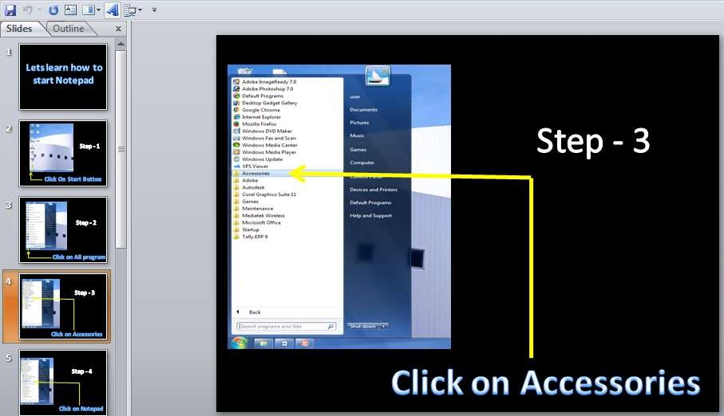

* + Press CTRL + M (new slide) ▪ Click on text box & insert your text. ▪ Press CTRL + M (new slide)

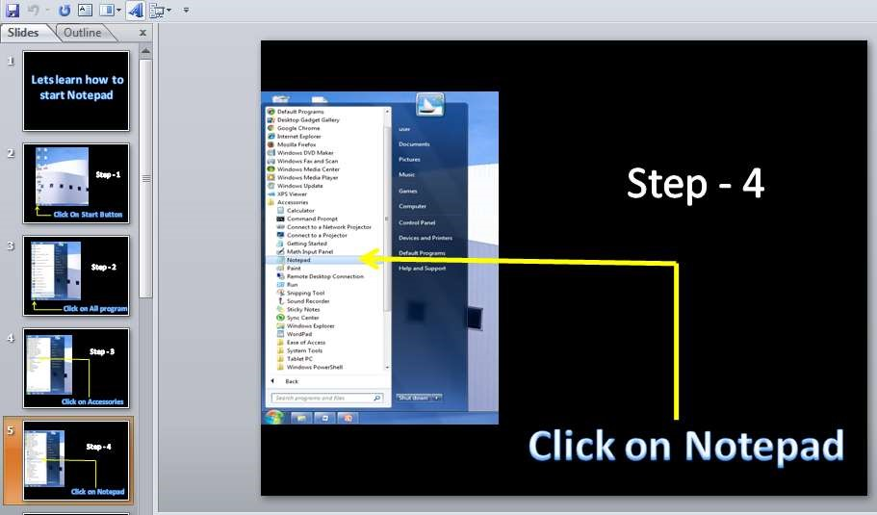

▪

Click on text box

& insert your text.

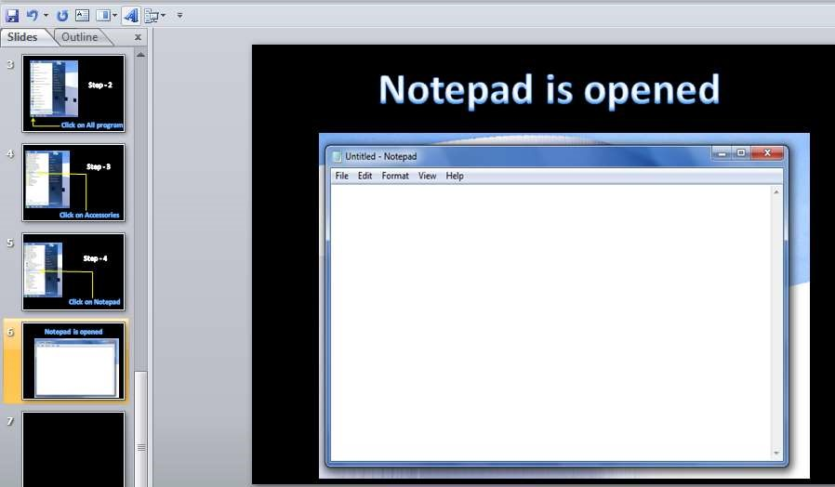

### To Applying Animations

* Select the text or object on the slide you want to animate.
* Select the animation tab.
* Click on custom animation drop-down menu in animation group like- Entrance, Exit, Motion. Apply any animation in each slides. ▪ Click on play button to see animation view in normal view.

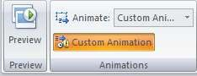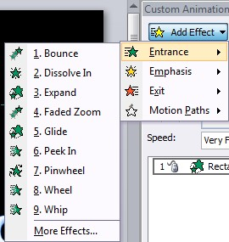

⇦ **To preview an animation effects.** ⇨

* insert timing

▪

Click on

animation tab

▪

click on automatically after option

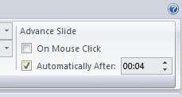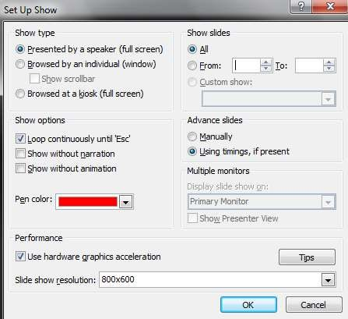

* click on apply to all
* click on slide show tab
* click on setup slide show
* Tick on – loop continuously until option.
* Click on ok

* Press **f5** (presentation view)

To Return Normal View – Press ESC Key .

### ⇦ How To Remove Animation. ⇨

In ppt you can remove & modify animations apply to an object for another .

* Click on animation tab
* click on custom animation

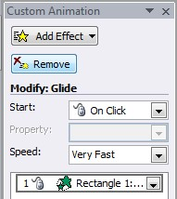

* click on animated object
* click on remove button for remove animation
* Or click on add effect button for modify animation

### ⇦ Short Key Of Powerpoint ⇨

|  |  |  |  |
| --- | --- | --- | --- |
|  |  |  |  |
| **To do this** |  |  | **Press** |
| 1. Duplicate object & text box. |  |  | CTRL + D |
| 2. Insert new slide |  |  | CTRN+M |
| 3. Animation preview |  |  | f5 |
| 4. Return normal view |  |  | ESC |
| 5. Close power point |  |  | CTRL+Q |
| 6. Create new presentation |  |  | CTRL+N |
| 7. Go to next slide |  |  | Page Down |
| 8. Go to previous slide |  |  | Page Up |
| 9. Show or hide grid |  |  | Shift + f9 |
| 10. Show or hide guide |  |  | Alt + f9 |
| 11. Group item |  |  | CTRL+G |

## MS-Access

**1.What is Ms- Access?**

Microsoft office access is a database management system used to store and manage data & is made for business and enterprises users. That help you store information for reference, reporting and analysis. It was first released on 13 Nov. 1992.(first version 1.0)

Component of ms access

* Tables
* Queries
* Relationship
* Macros
* Form
* Report
* Module

**How to open ms-access**

Click on start button > click on all program > click on Microsoft office > click on Microsoft office access .

1. Table Design

* + Open ms – access
  + Click on blank database.
  + Insert your file name > create

⇨

Click on Home.

⇨

click on view option > click

on design view option.

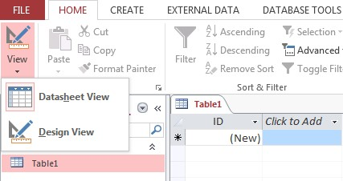

⇨

Insert your table name

⇨

Click on ok

⇨

Enter the name

of field that you

want to use. & click the data type

arrow a data type for the

field.

Like

-

text, numbers, hyperlink,

& attachment.

⇨

When your finish adding field

click the close button

⇨

Click yes to save your changes

⇨

Right click on table option

⇨

Click on “open”

⇨

Insert your data.

⇨

click on close button

⇨

save

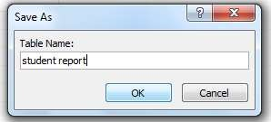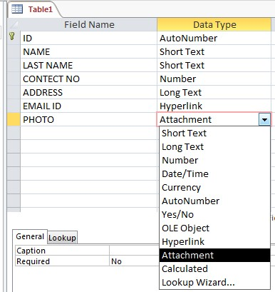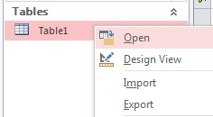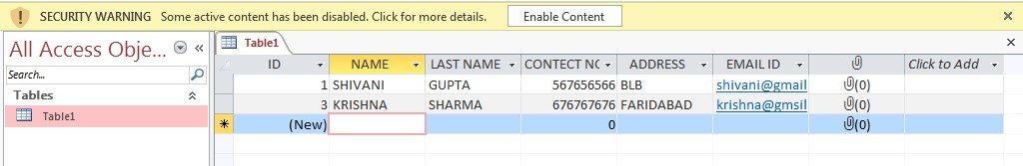

* + ok

**2. Form Design**

After generate table you can create a form & controls from buttons.

* + Click on create tab
  + Click on form Design Option (display the field list )
  + Double click on each field (table that contain the field that you want to see on the form)

Creating

buttons in access

–

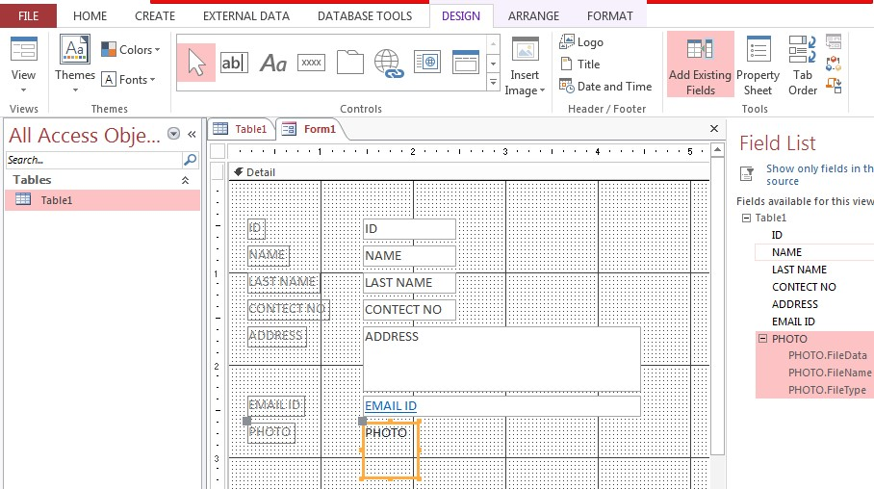

⇨

Click on button optio

n

Create button on form

(

a dialog box will be

open after create

button)

⇨

Set command on each

buttons

⇨

Click on next

⇨

Click on finish

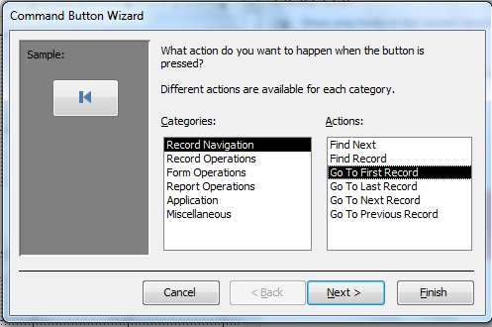

* + After create buttons the display of button below :

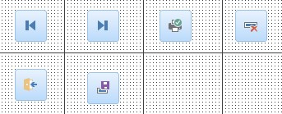

Check Form view –

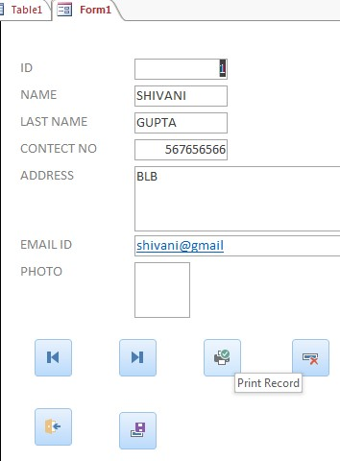

* + Click on view option
  + Click on form view option
  + Click on each buttons for open command. (that you want set on each buttons)

3. Create drop down list (lookup wizard)

* + After Design table click on design view

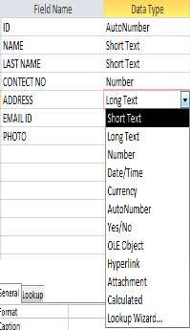

* + Click on data type of any field
  + Click on drop down button
  + Click on lookup wizard

* + Click on this option

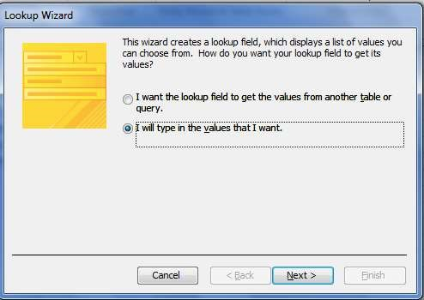

* + click on next
  + Insert your data in columns

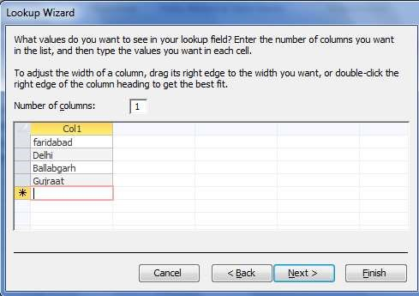

* + Click on next

⇨

Click on finish

⇨

Open table

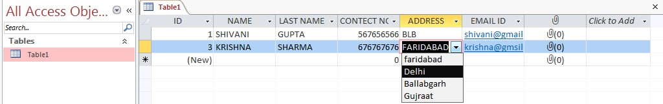

4. Generate Marksheet

* + Open ms – access
  + Click on blank database option. ⇨ Insert your file name > create ⇨ Click on Home.
  + Click on view option > click on design view option
  + Insert your table name
  + Click on ok
  + Enter the name of field that you want to use. & click the data type arrow a data type for the field. Like- text, numbers & hyperlink.

⇨

click on close button

⇨

yes

⇨

ok

⇨

click on create

⇨

click on query

design option

⇨

click on file name

⇨

click on Add

⇨

Click on close

⇨

A dialog box will

be open “press

CTRL+ A” on

dialog box for

select all field

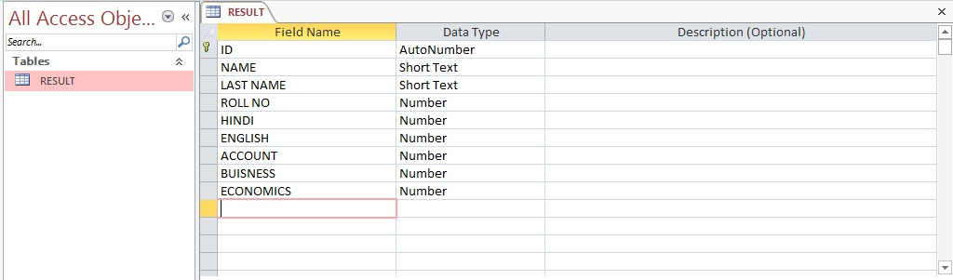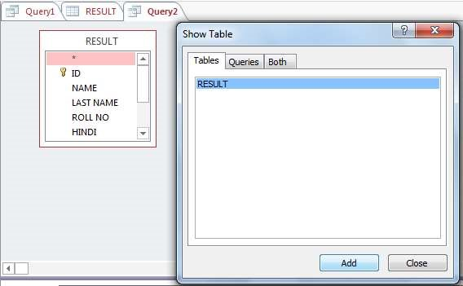

* + Drag this field with mouse left click (bottom)

Insert formula:

Total

**:**

Hindi+ English+ Account+ Business+ Economics

-

Press Enter

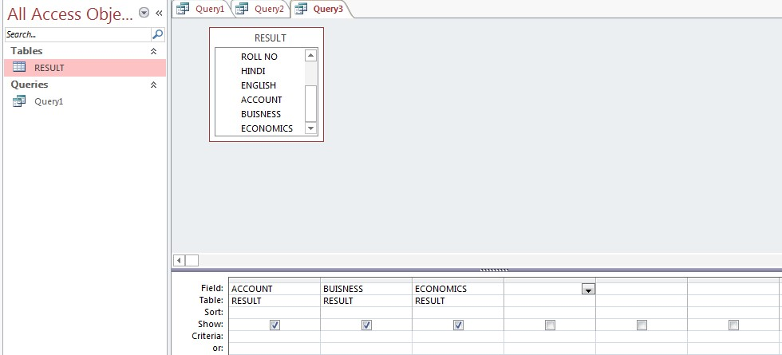

Per

**:**

Total

**/**

**5**

**:**

Total

**:**

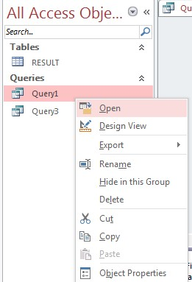

* + Click on close button
  + Click on ok
  + Right Click on your query name.

* + Click on open

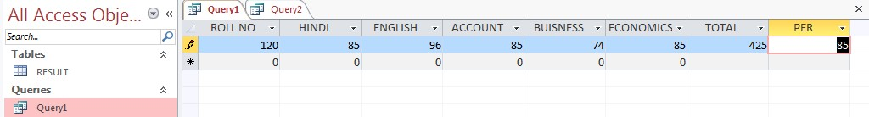

5.Create Relationship

A relationship in access help you combine data from different tables. Each relationship consists of field in two table with corresponding data. When you use related table in query, the relationship lets access determine which record from each table to combine in the result set.

* Open MS –Access
* Click blank database
* Insert file name
* Click on create
* Click on create menu > click on table design option

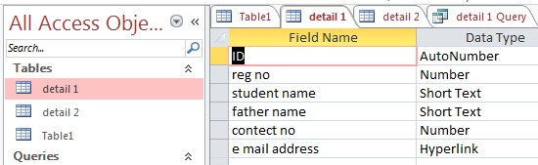

Table 1

* Click on close button

(you have to be create two file with different fields)

* Click on create menu > click on table design option⇨ on

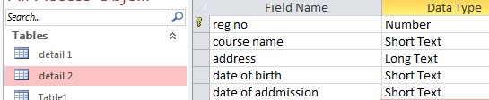

Table

2

* Click on close button
* Right click table 1 > open > fill details in table 1

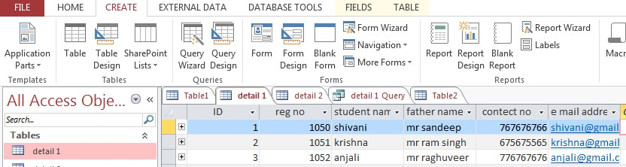

Table 1

* Click on close button
* Right click on table 2 > open > fill details in table 2

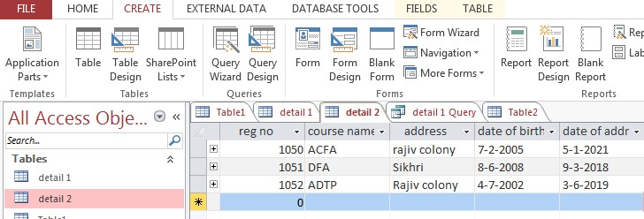

Table

2

⇨

Click on close button

⇨

Click on create menu

⇨

Click on query wizard

⇨

Click on ok

⇨

Select your table

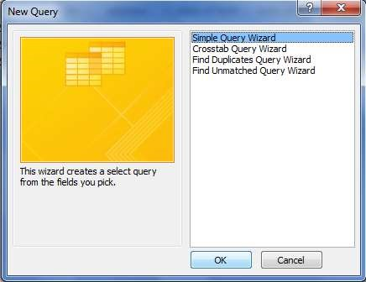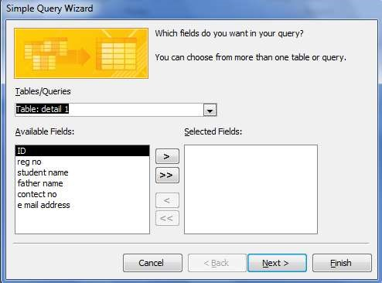

* Click on arrow button(forward field in selected field box)
* Click on finish

⇨

Select table 2

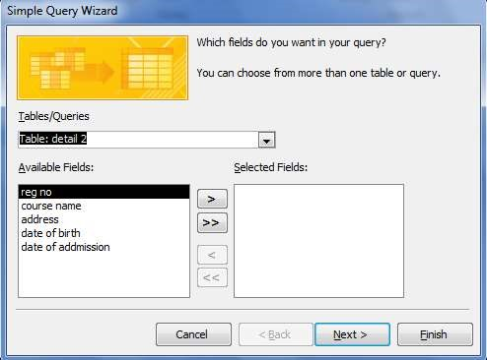

* Click on arrow button(forward field in previous table)
* Click next
* Click finish
* Click create

⇨

Click query design

⇨

Click on each field

⇨

Click on

add

⇨

Click on close

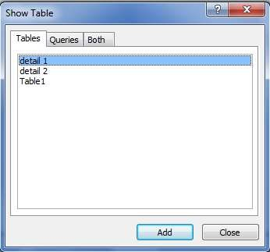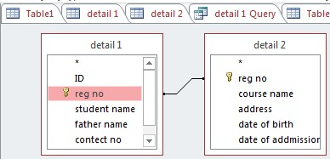

* Drag “Reg. no.” from table 1 to table 2⇨ Right click on query name

⇨

Click open

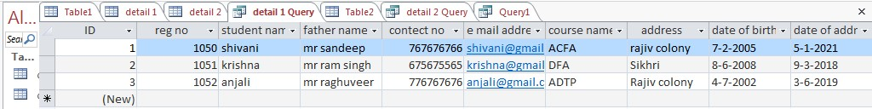

Two table data has been combine in one table.

**MICROSOFT OFFICE EXCEL**

*Ms-Excel is A Software Program Created By Microsoft .Ms-Excel Is*

*The Part Of Ms-Office . It Is A Spread Sheet That Can Present Data*

*In Number , Formula & Function In Worksheet . Worksheet Divide In Rows & Columns . A Particular Name Of Every Rows & Columns . Many Versions Available In Market Of Excel. Like – Ms-Excel 2002 , Ms- Excel 2003 , Ms-Excel 2007 , Ms-Excel 2010(New Version).*

*.Xlx is Extension Name Of Ms-Excel 2003*

*.Xlxs is Extension Name Of Ms- Excel 2007*

***How To Open Ms-Excel ?***

*Click On Start Button >All Programs >*

*Microsoft Office> Click On Microsoft Office Excel*

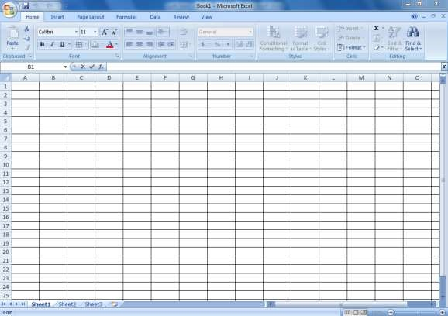

CURRENT CELL

POINTER



FORMULA BAR



TITLE BAR



MENU BAR



CLOSE



MAXIMIZ



MINIMIZE



SHEET NAME



SHEET TAB

SCROLLING



HORIZENTAL

SCROLL BAR



COLUMN



ROW



CELL



**SCROLL**

**BAR**

**MS-EXCEL 2003**

|  |  |  |
| --- | --- | --- |
| ROWS | COLUMNS | CELLS |
| 65536 | 256 | 16,77,7216 |

### MS-EXCEL 2007

|  |  |  |
| --- | --- | --- |
| ROWS | COLUMNS | CELLS |
| 10,48,576 | 16,384 | 17,17,98,69,184 |

***How To Calculate Rows , Columns & Cells ?***

***ROWS -*** *=Rows(Ctrl +Shift +Down Arrow) > Enter*

***COLUMNS -*** *=columns(Ctrl +Shift +Right Arrow ) > Enter*

***CELLS -*** *=Select Rows Value * Select Columns Value > Enter*

**1. MATH TABLE**

*1.*

*Put 1 In Any One*

*Cell*

*2.*

*Put 1 In Second Cell*

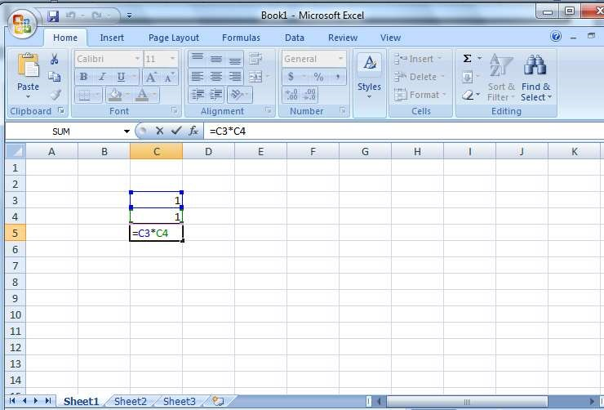

1. *= Select First Cell *Select Second Cell > Enter*

*Show 1 In Third Cell*

1. *Select The Area Of Column As Far As You Want To Table*

*Insert >Put Counting To Third 1 In Columns (2 To 10 That*

*You Want)*

*5.Select The Area Of Row As Far As You Want To Table*

*Insert > Put Counting To Third 1 In Columns ( 2 To 10 That*

*You Want)*

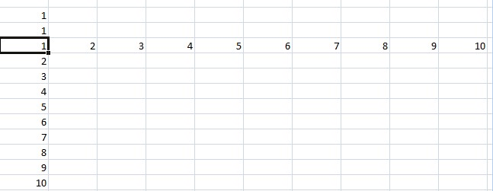

*6 . Select Table To Third 1 > Click On Data Menu*

*Click On “What If Analysis Option “*

*Click On Data Table Option*

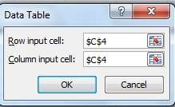

**SELECT FIRST 1**



**SELECT**

**SECOND**

**1**

*Click On Ok Option*

***2. Date Of Birth****.*

|  |  |  |  |  |  |  |
| --- | --- | --- | --- | --- | --- | --- |
| ***S. No.*** | ***Name*** | ***DOB*** | ***Years*** | ***Months*** | ***Days*** | ***Total Days*** |
| *1* | *Mohit* | *4/5/1998* | *22* | *8* | *29* | *8188* |
| *2* | *Sachin* | *1/8/2000* | *20* | *6* | *1* | *7381* |
| *3* | *Manish* | *12/2/1995* | *25* | *11* | *21* | *9350* |

***YEARS*** *- =Datedif(Select Dob,Today(),”Y”) >Enter*

***MONTHS*** *- =Datedif(Select Dob,Today(),”YM”) >Enter*

***DAYS*** *- =Datedif(Select Dob,Today(),”Md”) >Enter*

***TOTAL DAYS*** *- =Days360(Select Dob,Today()) > Enter*

### 3. Discount Sheet

|  |  |  |  |  |  |  |  |  |
| --- | --- | --- | --- | --- | --- | --- | --- | --- |
| ***S.NO.*** | ***Name*** | ***Product*** | ***UNIT*** | ***UNIT RATE*** | ***Total***  ***Amount*** | ***Dis.***  ***Rate*** | ***Dis.***  ***Amount*** | ***Total Pay Amount***  ***After Dis.*** |
| ***1*** | *Neha* | *MONITOR* | *12* | *14000* | *168000* | *5%* | *8400* | *159600* |
| ***2*** | *Kavita* | *MOBILE* | *6* | *7000* | *42000* | *4%* | *1680* | *40320* |
| ***3*** | *Rakhi* | *BEG* | *8* | *1200* | *9600* | *5%* | *480* | *9120* |

***Total Amount*** *- = UNIT *UNIT RATE*

***Discount Amount*** *- = Total Amount*Discount Rate*

***TOTAL PAY AMOUNT AFTER DISCOUNT -*** *= Total Amount - Discount Amount*

### 4. salary sheet

|  |  |  |  |  |  |  |  |  |  |  |
| --- | --- | --- | --- | --- | --- | --- | --- | --- | --- | --- |
| ***S.***  ***no.*** | ***name*** | ***Post name*** | ***Basic salary*** | ***D.A. 10%*** | ***HRA 6%*** | ***CTA 7%*** | ***EPF 12%*** | ***ESI***  ***2%*** | ***Gross salary*** | ***Net salary*** |
| ***1*** | *Gourav* | *Supervisor* | *60000* | *6000* | *3600* | *4200* | *7200* | *1200* | *82200* | *73800* |
| ***2*** | *Neha* | *HR* | *45000* | *4500* | *2700* | *3150* | *5400* | *900* | *61650* | *55350* |
| ***3*** | *Mamta* | *Accountant* | *50000* | *5000* | *3000* | *3500* | *6000* | *1000* | *68500* | *61500* |

***D.A. =*** *Dearness Allowance*

***HRA =*** *House Rent Allowance*

***CTA =*** *Conveyance Travelling Allowance*

***EPF =*** *Employee**Provident Fund*

***ESI =*** *Employee state insurance*

***D.A. =*** *Basic Salary *10%*

***HRA =*** *Basic Salary *6%*

***CTA =*** *Basic Salary *7%*

***EPF*** *= Basic Salary *12%*

***ESI =*** *Basic Salary *2%*

***Gross Salary =*** *Sum(Select Basic Salary Da Hra Cta Esi Epf) > Enter*

***Net salary =*** *Gross Salary – EPF - ESI*

### 5. Payroll Report

|  |  |  |  |  |  |  |  |  |  |  |  |  |  |  |
| --- | --- | --- | --- | --- | --- | --- | --- | --- | --- | --- | --- | --- | --- | --- |
| ***S. No.*** | ***Name*** | | ***Post Name*** | | | ***Basic Salary*** | | ***Present*** | | ***Absent*** | | ***Per day Salary*** | | ***Per hour Salary*** |
| *1* | *Rachna* | | *Accountant* | | | *60000* | | *28* | | *2* | | *2000* | | *250* |
| *2* | *Muskaan* | | *HR* | | | *18000* | | *25* | | *5* | | *600* | | *75* |
| ***Advance.*** | | | ***Overtime HOURS*** | | ***O. T.***  ***salary*** | ***Present Salary*** | | ***Net***  ***Salary*** | | ***Pay***  ***Salary*** | | ***Pending*** | | ***Clear/Pending*** | | |
| *5000* | | | *72* | | *18000* | *56000* | | *69000* | | *60000* | | *9000* | | *Pending* | | |
| *3000* | | | *45* | | *3375* | *15000* | | *15375* | | *15375* | | *0* | | *clear* | | |

***Per day salary*** *= Basic/30*

***Per hour salary =*** *per day salary /8*

***Overtime salary =*** *per hour salary*overtime*

***Present salary*** *= Per Day Salary *Present day*

***Net salary*** *= Present Salary + overtime salary* ***-*** *advance*

***Pending salary*** *= Net Salary* ***-*** *Pay Salary*

***Clear / pending*** *= If(Select Pending Salary =0,”Clear”,”Pending”)*

#### *6. Installment Calculation*

|  |  |  |  |  |  |  |  |
| --- | --- | --- | --- | --- | --- | --- | --- |
| ***s.no.*** | ***name*** | ***Product*** | ***Unit*** | ***Unit Rate*** | ***Total***  ***Amount*** | ***Down payment*** | ***Amount***  ***after***  ***down payment*** |
| *1* | *Umesh* | *computer* | *4* | *60000* | *2400000* | *80000* | *160000* |
| *2* | *Ankit* | *car* | *2* | *600000* | *1200000* | *700000* | *500000* |

|  |  |  |  |  |  |
| --- | --- | --- | --- | --- | --- |
| ***month*** | ***installment*** | ***interest*** | ***Interest with installment*** | ***Total installment*** | ***Grand total*** |
| *8* | *20000* | *600* | *20600* | *164800* | *244800* |
| *24* | *20833.3333* | *625* | *21458.333* | *515000* | *1215000* |

***Total =*** *Unit Rate * Unit*

***Amount after down payment =*** *total – down payment*

***Installment =*** *amount after down payment/month*

***Interest =*** *installment *3%*

***Interest with installment =*** *installment +interest*

***Total installment =*** *interest with installment *month*

***Grand total =*** *down payment +total installment*

### 7. Loan Calculate

|  |  |  |  |  |
| --- | --- | --- | --- | --- |
| ***S. NO.*** | ***Name*** | ***Bank Name*** | ***Loan Amount*** | ***Month*** |
| *1* | *PRIYA* | *SBI* | *200000* | *12* |
| *2* | *SUMAN* | *PNB* | *300000* | *10* |

|  |  |  |  |
| --- | --- | --- | --- |
| ***Rate*** | ***Pmt*** | ***Ipmt*** | ***Ppmt*** |
| *12%* | *17,769.76* | *2000* | *213,237.09* |
| *8%* | *31,110.96* | *2000* | *311.109.63* |

***Pmt -*** *Per Month Term*

***Ipmt -*** *Interest Per Month Term*

***Ppmt -*** *Principle Per Month Term*

***Pmt =****Pmt(Interest Rate Select /12,Month,Loan Amount)*

***Ipmt =****IPmt(Interest Rate Select /12,1,Month,Loan Amount)*

***Ppmt =*** *Pmt * Month*

*ALT + H+ K = Remove Currency Symbol Or Click On Home Tab >Click*

*On General .*

#### *8. MARK SHEET*

|  |  |  |  |  |  |  |  |  |
| --- | --- | --- | --- | --- | --- | --- | --- | --- |
| ***S.NO.*** | ***NAME*** | ***CLASS*** | ***ROLL NO.*** | ***HINDI*** | ***ENGLISH*** | ***ACCOUNT*** | ***ECONOMICS*** | ***BUISNESS*** |
| 1 | RAM | 12TH | 35 | 85 | 95 | 84 | 95 | 74 |
| 2 | BABULAL | 12TH | 36 | 74 | 75 | 85 | 85 | 60 |
| 3 | JAI | 12TH | 37 | 85 | 65 | 74 | 84 | 67 |

|  |  |  |  |  |  |  |  |
| --- | --- | --- | --- | --- | --- | --- | --- |
| ***Total*** | ***Obtain Marks*** | ***Max.*** | ***Min.*** | ***Percentage*** | ***Grade*** | ***Rank*** | ***Result*** |
| - | 500 | - | - | - | - | - | - |
| *-* | *500* | *-* | *-* | *-* | *-* | *-* | *-* |
| *-* | *500* | *-* | *-* | *-* | *-* | *-* | *-* |

***TOTAL =*** *sum(select all marks) > Enter*

***MAXIMUN =*** *Max(Select all Marks) > Enter*

***MAINIMUN =*** *Min(Select all Marks) > Enter*

***PERCENTAGE =*** *Average(Select all Marks) > Enter*

***GRADE =*** *If(Select Percentage>90,”A”,*

*If(Select Percentage>80,”B”,*

*If(Select Percentage>70,”C”,*

*If(Select Percentage>60,”D”)))) > Enter*

***RANK =*** *If(Select Percentage>90,”1”,*

*If(Select Percentage>80,”2”,*

*If(Select Percentage>70,”3”,*

*If(Select Percentage>60,”4”)))) > Enter*

***RESULT*** *= if(min(select all marks)>=35,”pass”,”fail”) > Enter*

#### *9.SALE REPORT*

|  |  |  |  |  |  |  |  |  |
| --- | --- | --- | --- | --- | --- | --- | --- | --- |
| ***S .No.*** | ***Name*** | ***Jan.*** | ***Feb.*** | ***March*** | ***April*** | ***May*** | ***June*** | ***July*** |
| *1* | RAMVIR | 1500 | 1700 | 2000 | 2500 | 3000 | 3500 | 3700 |
| 2 | MANOJ | 1200 | 1800 | 1700 | 1500 | 2500 | 3500 | 7100 |

|  |  |  |  |  |  |  |  |  |
| --- | --- | --- | --- | --- | --- | --- | --- | --- |
| **August** | **Sept.** | **Oct.** | **Nov.** | **Dec.** | **Total**  **Amount** | **Expenses** | **Commission** | **Net**  **SALES**  **AMT** |
| 3800 | 3900 | 4000 | 5000 | 2000 | - | 5000 | - | - |
| 8500 | 8600 | 7000 | 8500 | 9500 | - | 8000 | - | - |

***Total Amount*** *=Sum(Select All Amount ) > Enter*

***Commission*** *= Total Amount *5%*

***Net Profit***  *= Total Amount –Expenses – Commission*

##### 10. INVOICE BILL WITH GST

|  |  |  |  |  |  |  |  |  |  |
| --- | --- | --- | --- | --- | --- | --- | --- | --- | --- |
| **S.No.** | **Name** | **Item**  **Name** | **Unit** | **UNIT Rate** | **Total**  **Amount** | **Tax type** | **Tax rate** | **Tax amount** | **Total**  **Amount with tax** |
| 1 | RAM | COMPUTER | 5 | 1500 | - | IGST | 18% | - | - |
| 2 | GOPAL | MOUSE | 50 | 120 | - | IGST | 18% | - | - |

**GST -** Goods & Service Tax (indirect tax)

**CGST -** CENTRAL GOODS & SERVICES TAX

**SGST -**  STATE GOODS & SERVICES TAX

**IGST -** INTEGRATED GOODS & SERVICES TAX

**Total Amount** = Unit * Rate

**Tax Amount** = Total Amount * Tax Rate

**Total Amount With Tax**  = Total Amount+ Tax Amount

###### 11. ATTENDANCE REPORT

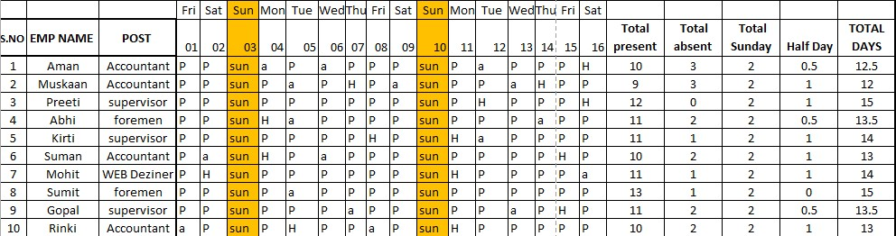

TOTAL

**Date** *insert date in cell and click on second*

*=select first date + 1  Enter  Select The*

*Area That You Want To Put Date  ctrl + R*

**Week Days** = text (select date,”ddd”) > Enter

***Total Present*** *= countif(select all Range ,”p”) > Enter*

***Total Absent*** *= countif(select all Range ,”A”) > Enter*

***Total Sunday***  *= countif(select all Range ,”Sun”) > Enter*

***Total Half day***  *= countif(select all Range ,”H”)* 0.5 >Enter*

***Total days***  *= total present +total Sunday + total Half day>Enter*

##### 12. V LOOK UP (1)

*V Look Up Stand For “Vertical Lookup “ . It Is A Function That Makes Excel Search For A Certain Value In Columns .V look Up Function Return A Number Such As “0” As The Col_ Index _ Num Agrument .*

*Create Any Data In Work Sheet Like –*

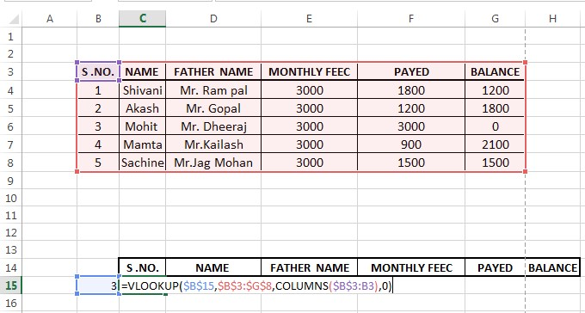

press Enter > select columns > press CTRL + R

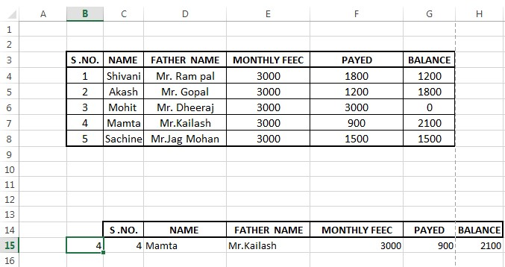

###### formula

= Vlookup(Select Blank Cell F4,Select All Data F4,Columns( column & row Name F4: column & row Name),0) > Press Enter .

##### 13. V lookup (2)

*Create Any Data In Work Sheet*

*Select headings & copy > click on any cell*

*click on paste option > paste special > transpose > ok*

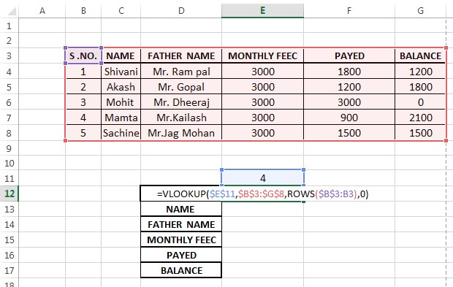

###### Formula

= Vlookup(Select Blank Cell F4,Select All Data F4,Rows( columns & row Name F4: column & row Name),0) > Press Enter .

Select Rows > Press Ctrl +D (Formula Follow In Rows)

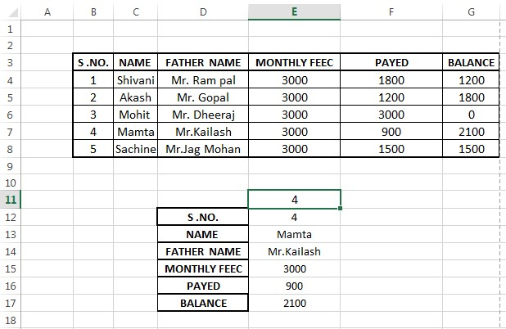

**13. H lookup**

H Look Up Stand For “Horizontal Lookup “ . It Is A Function That

*Makes Excel Search For A Certain Value In Columns .H look Up Function Return A Number Such As “0” As The Col_ Index _ Num Agrument .*

*Create Any Data In Work Sheet(Horizontal pane)*

*Select headings & copy > click on any cell*

*click on paste option > paste special > transpose > ok*

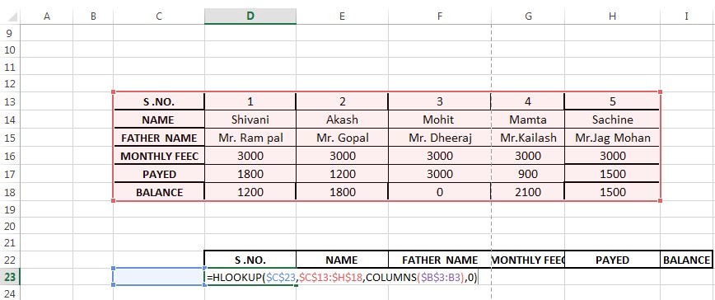

###### Formula

= Hlookup(Select Blank Cell F4,Select All Data F4,Columns( column & row Name F4: column & row Name),0) > Press Enter .

Select Columns > Press Ctrl +R (Formula Follow In columns)

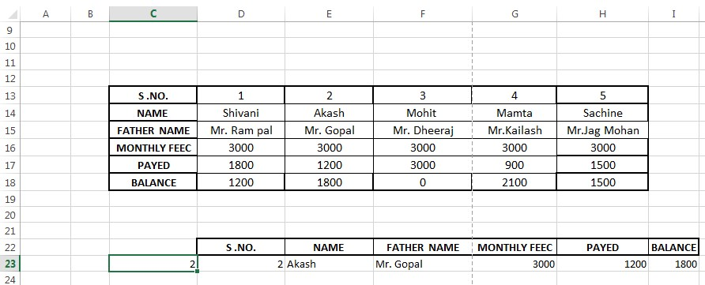

**Excel Functions**

***(HOME functions)***

***Wrap Text -*** *on the home tab , in the alignment group ,click wrap*

*text . this function used to data in the cell wrap to fit the column width , so If you changed the column width adjust automatically .*

*Insert your data in cell > click on wrap text function.*

*Short key of wrap text = ALT + H + W*

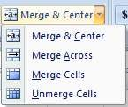

*You can merge cell in excel as a quickly & easy and data neatly across column & row . this function given a different types of merge .*

**Merge Center** - *Used To Ideal For A Title .*

**Merge Across** - *Which Merge A Cell Across Number.*

**Merge Cell** - *Used To Combination Of Both Row &* *Column.*

**Unmerge Cell** *- Used To Unmerge Cells .*

*Select The Cells You Want To Merge And Center. >*

*Click On Merge & Center > Select Any Option That You*

*Want .*

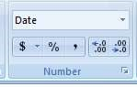

*In excel you can format your number in cell like - currency , percentage , decimals , dates , social security , accounting & fraction .*

.

*The*

*formatted with the general*

*format are displayed just the way*

*you type them*

.

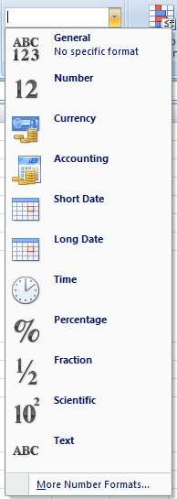

*Use the general display of*

*numbers.(decimal places)*

*Use the general monetary value*

*and display the currency*

*symbol .*

*Align the currency symbol*

*Displays date & time serial*

*number as date value*

*according to the type &*

*Multiple the cell value by 100*

*and display the result with a*

*(*

*%) symbol .*

*Display a number as a fraction*

*according to the type of*

*fraction*

*Scientific format Displays*

*Text Format*

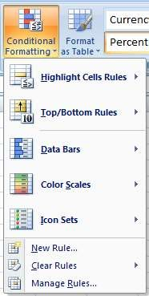

*Conditional Formatting Used To Apply*

*Formatting Like - Color , Icon , bar , Based On Cell Value . Icon Set In Criteria.*

*Example – If Value Is Less Then . Colored The Cell .*

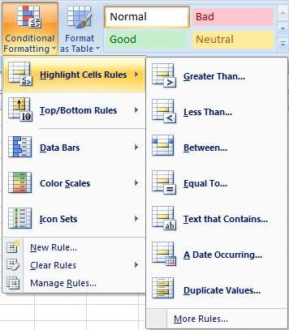

***High Light Cell Rules***  *- To High Light Cell Are Greater & less, equal to,*

*Between , & duplicate value. Then a value .*

*Steps -*

1. *Select range.*
2. *Click on any option of high light cells . that you want .*

*3.*

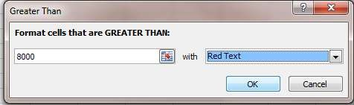

*Ok*

*A date Occuring - This Option Used To Find Out Today & Previous*

*Date.*

*Steps -*

* 1. *Insert dates in cells*
  2. *Click on this option & select any date that you want.*

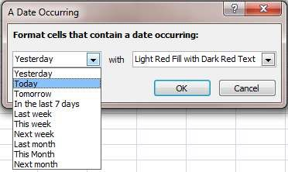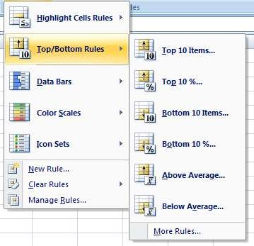

*The excel coditional formatig top and bottom rules allow how to apply formating to cell that statistical condition to other cell the range .(above average , top 10% )*

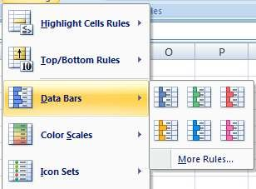

*Data Bars Help How To Spot Large And Simimlar Number . A Longer Bar Value Show Large Value & A Small Value Bar Show Samll Value.*

1. *Select The Range Of Cell That You Want To Apply Fomating.*
2. *Click On Data Bars That Under On Conditinal Formating .*
3. *Select Any Color.*

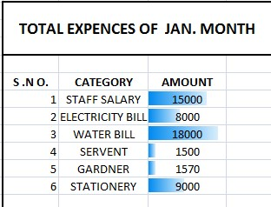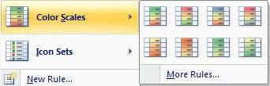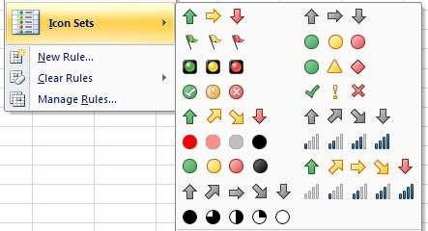

|  |
| --- |
|  |

*Color Scale & Color Set Can Used To Understand Data Distribute And More Variaction .Cell Are Shed In Gradiant And More Color .*

*Three Color Are Correspond Show To Minimun , Mid & Maximum*

1. *Select The Range Of Cell That You Want To Apply Fomating.*
2. *Click On color scale or icons That Under in Conditinal Formating*

1. *Select Any Color or icons .*

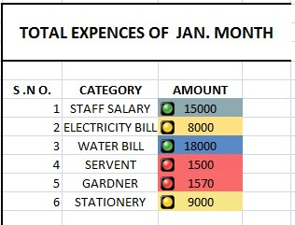

*Top Color Represent The Large Value , Center Represent The Middle Value & Bottom Color Represent The Small Value . Each Color And*

*Icon Represent The Value Of Cell .*

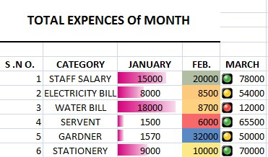

**DATA BARS**

**COLOR SCALE**

**SET ICONS**

*If You Want Remove Oll Formating Click On Clear Rules Option That Under In Conditional Formating > Click On Clear Formating Cell Option .*

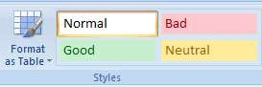

*This option used to format your data as a table . table can improve the look of your worksheet .but they will also help to show your content and make your data easier to use.*

* 1. *Select the cell*
  2. *Click on format as table option .*
  3. *Select a table style the drop down menu.*
  4. *A dialog box will appear to confirm selected cell range for the table.*

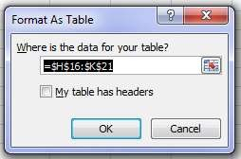

*Click on Ok*

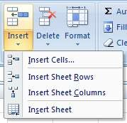

*This Option Used To Insert To Row And Columns .*

* + 1. *Select Any Cell / Rows / Columns. That You Want .*
    2. *Click On Insert Option > Select Any Option Like Insert Row/ Insert Column / Insert Sheet .*

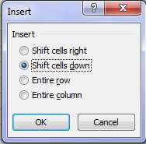

* + 1. *Click on ok .*

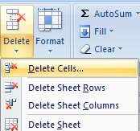

*This Option Used To Delete Row And Columns .*

* + 1. *Select Any Cell/ Rows / Columns. That You Want Delete.*
    2. *Click On In Delete Option > Select Any Option Like- delete Row/ delete Column / delete Sheet .*

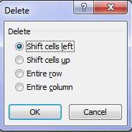

* + 1. *Click on ok .*

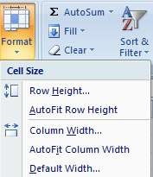

***Row & column height / width***  *- this option used to change the height & width of cell .*

* + - 1. *Click on selected cell*
      2. *Click on format option > click on row height*

*/column width (that you want change it .) 3. A dialog box will appear*

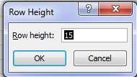

1. *Insert row & column height/width in dialog box.*

*Click on Auto Resize To Set The Width Or Height Automatically****.***

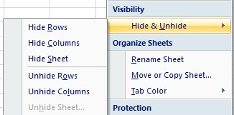

*This option used to how to hide & unhide column & rows. Or sheet.*

* + - 1. *Select row/column/sheet*
      2. *Click on format button under visibility ,point to hide & unhide and then select any option .*
      3. *Click to unhide row/column/sheet. To unhide row /column/sheet .*

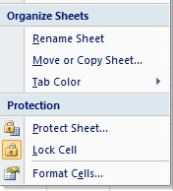

**Rename sheet  *-*** *this option used to rename your sheet.*

*Click on organize sheet option that under in*

*format button. > click on rename sheet option >*

*Insert sheet name that show in bottom of sheet.*

**Tab color**  *- this option used to change tab color.*

**Protect sheet**  *- To Prevent Other User From Accidentally*

*Changing , Moving , Deleting Data In*

*Worksheet You Can Lock The Worksheet &*

*Cell*

*1. Click on organize sheet option that under in format button. > click on protect sheet option*

*2.*

*Enter your password . > ok*

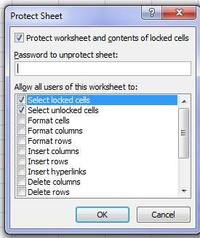

**LOCK CELL** *- This Option Used To Lock Cell .*

**FORMATE CELL -** *This Option Used To Format Your Cell In -*

*Currency , Date ,Time, Percentage Accounting*

*.*

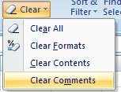

*This Option Used To Remove - Formates , Contents & Comments.*

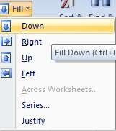

*Excel Fill Command Used To Fill Same Text Or Number That Form A Series . Its Example For Faster Of Copy & Paste .*

*CTRL + D Is The Short Key Of Fill Down CTRL + R Is The Short Key Of Fill Right.*

***We Can Also Series Menu To Filling Series Of Number.***

*Steps :*

1. *Enter 1 In First Cell> Press Ctrl +Enter To Keep The Cell Selected*
2. *Press & Hold The Ctrl Key*
3. *Click On Fill Option > Click On Series Option*
4. *Fill Step Value & Stop Value That You Want. In This Dialog Box.*

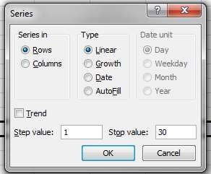

*Filter Option Most Commonly Used To*

*Specific Set Your Data . So You Can Filter A*

*Range And To Change The Order Of Your*

*Data , Sort It*

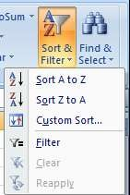

***Text filter***

*If Your Worksheet A Lot Of Content , It Can Be Difficult To Find*

*Information Quickly . Filter Can Be Used To Narrow Down The Data In Your Worksheet. Allowing To View Only The Information You Need.*

**Steps**

1. *Select All Data ( Check The Selected Area To Make Sure That The Data Is Included).*
2. *Click On Home Tab > Click Sort Filter >Click Filter Option.*

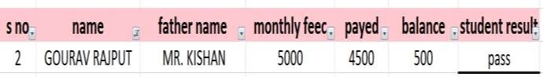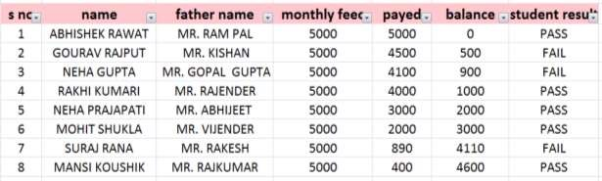

1. *Select Any Range That You Want Filter.*
2. *Click On Drop Down Button That Show In Headings.*
3. *Click on text filter option.*

*(in text filter option – you have given many option)*

1. *Click on any option that you want & click on ok.*

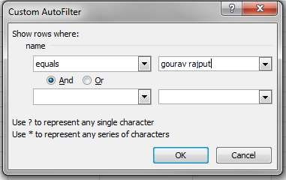

If you want to clear filter . so click on remove filter option

***(Insert function)***

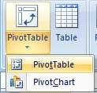

***Pivot table & pivote chart***

*Pivot table & pivot chart is connected to each other. You can find two dimensional Pivot Table . Pivot Table Allow To Create A Power Full View With Data Summarized In A Grid ( Horizontal & Vertical ). Pivot chart enable you to visualized data in multiple chart format .*

***Steps :***

***creating pivot table***

1. *Create Any Data In Excel Worksheet .*

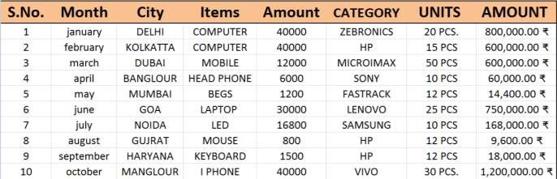

1. *Select Data & Click On Pivot Table Option. A Dialog Box Appear In Sheet.*

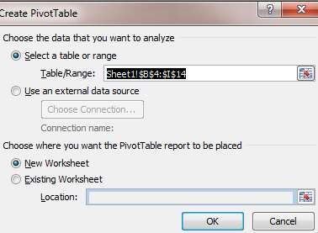

*If You Want That Pivot Table Show In New Worksheet So Click On*

*New Worksheet Option & If You Want That Pivot Table Show In Existing Worksheet So Click On Existing Worksheet Option . > ok.*

1. *Select The Field For View Pivot*

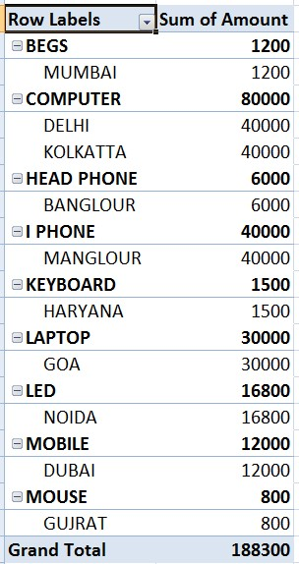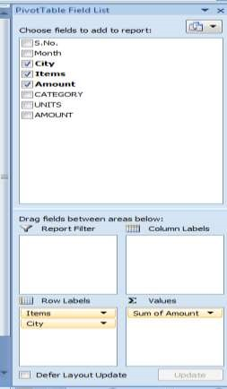

***Create pivot chart***

Steps

1. *select data.*
2. *Click on pivot chart option.(a dialog box will appear. click on new worksheet) > ok 3. Select the field for view pivot chart.*

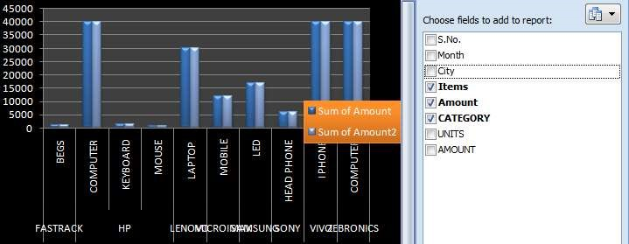

***(Page layout function)***

*Set Print Area - if you have print a specific selection on excel worksheet*

*so you define print area that include just the selection . when you define a print area. Only a printed area is printed. You can added the print area after set print area click on clear print area.*

Steps

1. *Select the area that you want to define*
2. *Click on page layout option > click on set print area option*
3. *Check print preview (press ctrl + f2)*

###### Text function ( formula’s)

*The text function used to change the way of number appear by applying formatting codes. Its use in situation where you want a display number in more readable format and you want to combine number a text.*

|  |  |
| --- | --- |
|  |  |
| **BAHTTEXT** - | *convert a number to text.* |
|  | *=Bahttext(select number) > Enter* |
| **CHAR** - | *convert specified the code number* |
|  | *=char(select number) > Enter* |
| **CLEAN** - | *remove non printable area* |
|  | *=clean(select text) > Enter* |

**CODE** - *return a numeric code in first character in text string*

*=code(select text) > Enter*

**CONCATENATE** - *concatenates a list of range of text.*

*=concatenate(select text 1, Select Text 2) > Enter* **DOLLAR** -*convert a number to text using currency format.*

*=Dollar (select no. , put decimal place) > Enter*

**EXACT**  - *if two text are string exactly same. Weither is true other wise false .*

|  |  |
| --- | --- |
|  | *=Exact(select text 1,select text 2, text 3) > Enter* |
| **FIND**  - | *return the starting position of one text string*  *within another text string.* |
|  | *=find(“find text”,with text) > Enter (show text value)* |
| **FIXED** - | *Round A Number To The Specified Number of* |

*decimal and return the result as text with or without commas.*

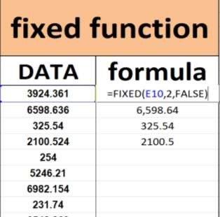

*If you want add a comma in number so insert “false” in formula. Other wise insert true .*

|  |  |
| --- | --- |
|  |  |
|  | *=Left(Select Text , Insert Text Value That You Want)*  *> Enter* |
| **LEN *-*** | *Return The Number Of Character In A Text*  *String . (Show All Character Value)* |
|  |  |
|  | *=Len(Select Text) > Enter* |

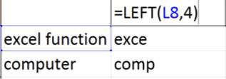

|  |  |
| --- | --- |
| **LEFT  *-*** | *return the specified number of character from the start text string .* |
|  |  |

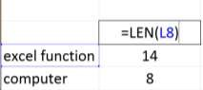

**LOWER *-*** *Convert All Text String In Lower Case.*

*=Lower( Select Text) > Enter*

**MID  *-*** *Return The Character Form. The middle of*

*supplying text string. The character exacted.*

*=mid ( Select Text, start number, no. of*

*character) Enter*

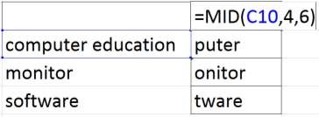

**PROPER -** *Convert A Text String In Proper Case.*

= *proper (select text ) > enter*

**REPLACE -** *replace part of text string with a different string.*

= *replace (select text, start no. ,replace text value, “new text “ ) > enter*

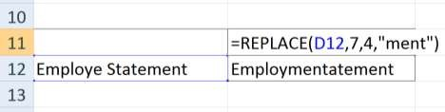

**REPT** *- Repeat Text Given No. Of Time.*

*=Rept(Select Text,Put Any Number) . > Enter*

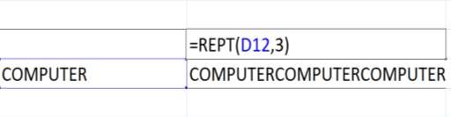

**RIGHT -** *Return The Specified Number Of End Of Text.*

*=Right(Select Text , Put Text Value)*

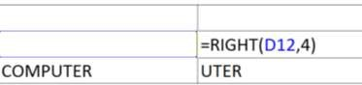

**SEARCH -** *Return The Number Of The Character At Which Specified Character. Or Text String In One Round.*

=Search (“find text”,with text) > Enter (show text value)

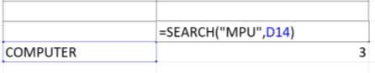

**SUBSTITUTE -** *Replace Existing Text With New Text.*

*=Substitute(Select Text ,”Old Text”,”New Text”) >*

*Enter*

**T**  *Weither Value Is Text And Return The Text If It Is.*

*=T(Select Text) > Enter*

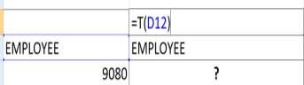

**TRIM -** *Remove Space*

*=Trim(Select Text) > Enter*

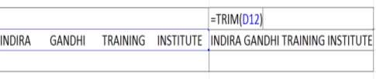

**UPPER -** *Convert A Text String In Upper Case.*

= *Upper(Select Text ) > Enter*

**VALUE -** *Convert A Text String That Represent A Number To A Number.*

= *Value(Select value + Add New Value ) > enter*

**DEEPAK SHARMA**

**Extension names**

|  |  |  |
| --- | --- | --- |
| **Application software** | **Extension name** | |
| Notepad | .Txt | |
| Wordpad | Rtf (Rich Text Format) | |
| Ms-Paint | Bmp (Bitmap Image) | |
| Microsoft Office Word | **2003** | **2007** |
| .Doc | .Docx |
| Power Point | .Ppt | .Pptx |
| Microsoft Office Excel | .Xls | .Xlsx |
| Ms- Access | .Mbd | .Accdb |

**DEEPAK SHARMA**

**Excel short key**

1. Merge cell - ALT + H+M+M
2. Cell merge according to text - ALT + O+C+A
3. Insert border on cells - ALT + H+B+A
4. Insert cell/row/column/sheet - CTRL +
5. Delete cell/row/column/sheet - CTRL -
6. Hide row - CTRL + (
7. Unhide any hidden row - CTRL + SHIFT + ( 8. Hide columns - CTRL + )
8. Unhide any hidden columns - CTRL + SHIFT + )
9. Outline border to selected cell - CTRL + SHIFT + & 11. Remove border to selected cell - CTRL + SHIFT + -

|  |  |  |
| --- | --- | --- |
| 12. Open chart |  | - F 11 |
| 13. Increase sheets |  | - SHIFT + F11 |
| 14. Check print preview |  | - CTRL + F2 |
| 15. Format cell |  | - CTRL + 1 |
| 16. Move to sheet |  | - CTRL + PAGE UP/PAGE DOWN |
| 17. Insert a new line in cell |  | - ALT + ENTER |
| 18. Filter data |  | - ALT + A + T |
| 19. Create table |  | - CTRL + L/T |
| 20. Current date |  | - CTRL + **;** |
| 21. Current time |  | - CTRL + SHIFT + **;** |
| 22. Centre content |  | - Alt + H+ Ac |
| 23. Middle content |  | - Alt +H +Am |

1. Font size - Alt + H + Fs
2. Fill color - Alt + H + H
3. Autosum - Alt + =
4. Wrap Text - Alt + H+ W

**ASSIGNMENT: A-1**

Student Name: _____________________ Father’s Name:____________________

Date of Exam: ______________ Reg. NO. :__________ Course Name: __________

Branch Name: _________________________ Exam Time:____________________

Max Marks: 25

Q1. What is Computer? Explain history of computer with pictures.

Q2. What is Deference between Laser Printer and Dot Matrix printer with pictures.

Q3. What is Storage Device ? Create a Chart of Storage Capacity with Explanation. Q4. Define Generations of Computer with Pictures.

Q5. How many types of Computer? Define Deference between Analog and Digital Computer.

Q6. How to Create, Save and Delete a Table in Ms-Word? Crate a Diagram of MS Word.

Q.7 What is use of Pivot Table in Ms-Excel? Explain Steps how to crate Pivot Table with Diagrams?

Q8. What is MS- Access ?How to Create a Report In Ms-Access?

Q9. How may types of Computer? What is Deference between Mainframe Computer and Super Computer.

Q10.What is Macro? Explain its advantages.